MAKE THE GRADE

SHAPE, SPACE & MEASURES

1.
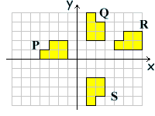

a) Describe fully the transformation of P R.

(2)

b) Describe fully the transformation of Q S.

(2)

2. Enlarge the trapezium by a factor of from the origin.
y
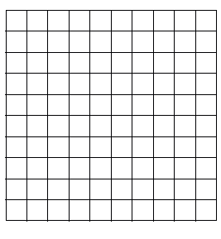
x
(3)

3. Calculate the areas of the following shapes:
(Take π=3)

a)
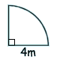
2m

(3)

b)
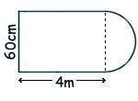

2m

(4)

4. Calculate the perimeter of a semi-circle radius 5cm. (Take π=3)

(3)

5. a) Calculate the volume of the world’s largest Toberlone piece shown below:

50cm

10cm
50cm

(5)
b) How many litres of chocolate are needed to make the piece?

(2)

“SUCCESS comes in ‘cans’ not ‘can’ts’”

6.

Calculate the volume of ‘success’ in the can shown.
(Height = 10cm and radius = 3cm - take π=3)

(4)

7. Mike reckons that 2∙5m³ is the same as 250cm³. Is he correct?
Explain your answer.

(3)

8. Find the missing sides of the following triangles:

a)

5cm
12cm

x

(3)

b)

x
6cm

10cm

(3)

9. Find the surface area of the solid shown below:

4cm

2cm

3cm

(6)

10. a) A regular polygon has an exterior angle of 45º. How many sides does it have?

(3)

b) Does this polygon tessellate with itself?

(1)

11. A ship leaves harbour A and sails on a bearing of 050º to harbour B. What is the bearing of harbour A from harbour B?

(2)

12. The Great Western Don’tStandSoCloseToMe (which looks like a cute bunny but isn’t!!!) has a nasty sting which it uses if people get too close to it. The zookeeper is trying to feed him. It is a particularly bad day and The Great Western Don’tStandSoCloseToMe is only happy if:
- the zookeeper doesn’t get any closer than 50cm to him
- the zookeeper stays closer to the North wall than him.

Shade on the diagram below the areas where the zookeeper is ‘safe’.

Use a scale of 1:10 and show all construction lines.

NORTH WALL

(5)

13. Construct a perpendicular bisector through point A. Show all construction lines

A
B

(3)
Assess your knowledge

Skill | Qu | ☺ | ☹
I can transform shapes using rotations and reflections | 1
I can transform shapes using enlargements | 2
I know the formula for the area of a circle | 3
I know the formula for the circumference of a circle | 4
I can calculate volumes of prisms | 5a,6
I can convert between units of volume and area | 5b,7
I can use Pythagoras to find missing sides in right angled triangles | 8
I can calculate the surface area of prisms | 9
I can calculate the exterior angle of a regular polygon | 10
I can solve problems involving bearings | 11
I can solve problems involving loci | 12
I can construct perpendicular bisectors using a pair of compasses | 13

☺ Yippee!! - I got all the questions correct.
☹ I made mistakes and need to practise this topic more.

Top 3 topics I need to revise are

If your score is:

46 – 57 - Well done. You are definitely working at grade C with your shape and space skills. Bring on the B !!!

29 – 45 - Promising work – make sure you ask for help and revise the topics that you had difficulty with. You can still get that C !!!

0 – 28 - Serious revision and help is needed. Sort it out now.
Don’t wait any longer

