ANSWERS  = 1 mark
MAKE THE GRADE

QUESTIONS
1 - 6

SHAPE, SPACE & MEASURES

1. a) Reflect triangle ABC in the x axis. Label the new triangle A’B’C’ (1)

b) Translate triangle A’B’C’ $(\left(\begin{matrix}\text{-4} \\ 0\end{matrix}\right))$. Label the image A’’B’’C’’ (1)

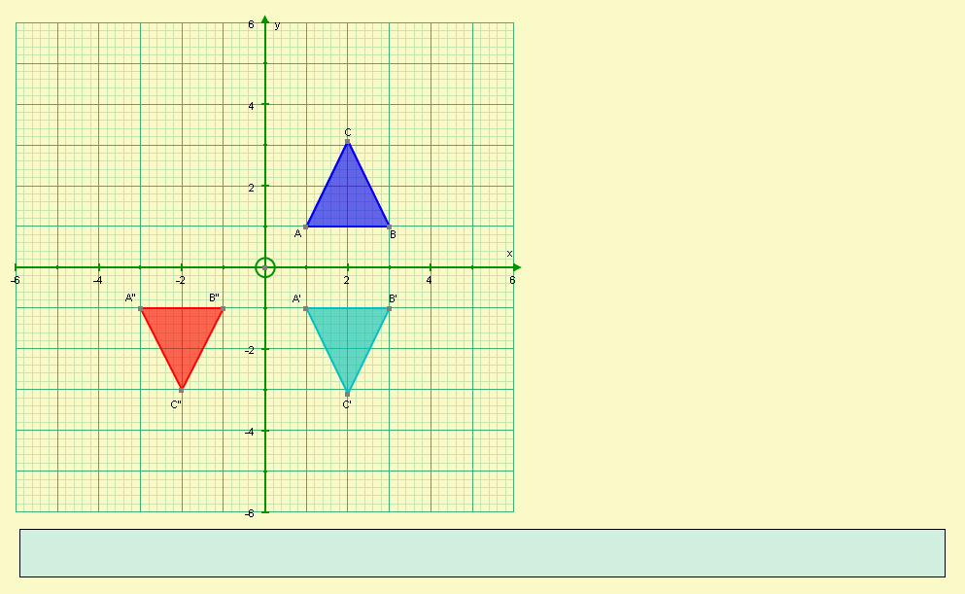



c) Describe the single transformation that will map triangle ABC onto triangle A’’B’’C’’

Rotation 180º clockwise ( or anticlockwise) about the origin (or (0,0))




(3)

x

2. Trapezia A and B are similar.
NOT TO SCALE

yº

30º

15cm

10cm

x
3cm

Calculate the values of:

- x $\begin{aligned}\frac{x}{3}=\frac{\text{10}}{\text{15}} \\ x=\frac{\text{10}}{\text{15}}\begin{matrix} \\ ×\begin{matrix} \\ 3=\frac{\text{30}}{\text{15}}=2\text{cm}\end{matrix}\end{matrix} \\ \end{aligned}$




- y 30º


(4)

3. Calculate the value of x in the diagram below:
NOT TO SCALE

x
5cm

5cm
2cm
6cm
 for diagrams

x
6cm
$$\begin{aligned}\frac{x}{6}=\frac{5}{2} \\ x=\frac{5}{2}x\begin{matrix} \\ 6=\text{15}\text{cm}\end{matrix}\end{aligned}$$

(3)
2cm
5cm


4. Find the value of a in the diagram below:
NOT TO SCALE

12cm

4cm

3cm
a
 for diagrams

$$\begin{aligned}\frac{a+3}{3}=\frac{\text{12}}{4} \\ a+3=\frac{\text{36}}{4}=9 \\ a=6\text{cm}\end{aligned}$$


4cm
12cm

3cm


a + 3 cm
(4)

5. x, y and z represent lengths in the following formulae. By considering dimensions, which of the formulae below could represent length (L), area (A) or volume (V)?

x+y+z | xyz | 3xy | x(y+z) | 4$π$x² | y²+2z | $$\frac{x+y}{z}$$
L | V | A | A | A | - | L







(6)

6. Find the missing angles in the diagrams below, giving reasons for your answers:

a)
90º

a
50º

O

a = 40º


because angles in a semi-circle is a right angle (and the sum of the angles in a triangle is 180 º)

(2)

b)

50º

O
b

c

b = 100º

because angle at the centre is twice the angle at the circumference
(2)

c = 110º


because opposite angles in a cyclic quadrilateral add up to 180 º

(2)

c)

e
d
20º
g

15º
f

d = 20º


because angles in the same segment are equal


(2)

e = 20º

because angles in the same segment are equal

(2)

f = 15º


because angles in the same segment are equal

(2)

g = 145º


because the sum of the angles in a triangle add up to 180º


(2)

- Find the missing side indicated in each the following triangles,

CALCULATORS ARE ALLOWED FOR QUESTIONS
7 - 10

giving your answer to a sensible degree of accuracy:

a)
NOT TO SCALE
H

12cm

$$\begin{aligned}O=\text{SXH} \\ a=\text{sin}\text{30}x\text{12} \\ a=6\text{cm}\end{aligned}$$
O

a
O
H
S

 for sine

30º



(3)
b)

$$\begin{aligned}A=\text{CXH} \\ b=\text{cos}\text{40}x\text{10} \\ a=7\text{.}7\text{cm}(1\text{dp})\end{aligned}$$
A
A
C
H
b
 for cosine


40º

10cm
H
(3)

c)

$$\begin{aligned}O=\text{TXA} \\ c=\text{tan}\text{40}x\text{12} \\ a=\text{10}\text{.}\text{07}m(2\text{dp})\end{aligned}$$

O
A
O
T
c
 for tangent

30º
40º

12m
A


(3)

$$\begin{aligned}A=\text{CXH} \\ x=\text{cos}\text{50}x8 \\ x=5\text{.}\text{1423}\text{.}\text{.}\text{.}\text{cm}(1\text{dp}) \\ d=2x5\text{.}\text{1423}\text{.}\text{.}\text{.}=\text{10}\text{.}3\text{cm}(1\text{dp})\end{aligned}$$

A
d)
H
H
C
8cm
8cm

 for cosine


50º
50º
x
d
A


(3)

e)

$$\begin{aligned}H=O÷S \\ e=5÷\text{sin}\text{50} \\ e=6\text{.}\text{53}m(2\text{dp})\end{aligned}$$
O
50º
H
S
O
5m
H
e
 for sine




(3)
O
f)
4cm

$$\begin{aligned}A=O÷T \\ f=4÷\text{tan}\text{70} \\ e=1\text{.}5\text{cm}(2\text{dp})\end{aligned}$$
A
f
O

A
T
70º

 for tangent

(3)



$$\begin{aligned}O=\text{TXA} \\ c=\text{tan}\text{40}x\text{12} \\ a=\text{10}\text{.}1\text{cm}(1\text{dp})\end{aligned}$$

$$\begin{aligned}O=\text{TXA} \\ c=\text{tan}\text{40}x\text{12} \\ a=\text{10}\text{.}1\text{cm}(1\text{dp})\end{aligned}$$

8. Find the missing angle indicated in each the following triangles, giving your answer to a sensible degree of accuracy:
NOT TO SCALE

a)
 for sine
H
$$\begin{aligned}\text{sin}a=\frac{0}{H}=\frac{8}{\text{12}} \\ a={\text{sin}}^{\text{-1}}(\frac{8}{\text{12}})=\text{41}\text{.}8^{∘}(1\text{dp})\end{aligned}$$
12cm


8cm
O


a

 for tangent
(3)
b)
A
$$\begin{aligned}\text{tan}b=\frac{0}{A}=\frac{5}{9} \\ b={\text{tan}}^{\text{-1}}(\frac{5}{9})=\text{29}\text{.}1^{∘}(1\text{dp})\end{aligned}$$
O

5cm
9cm



b
(3)

c)
 for tangent
$$\begin{aligned}\text{tan}c=\frac{0}{A}=\frac{\text{80}}{\text{120}} \\ c={\text{tan}}^{\text{-1}}(\frac{\text{80}}{\text{120}})=\text{33}\text{.}7^{∘}(1\text{dp})\end{aligned}$$


80cm
O


c
30º
1.2m
A

(3)
 for cosine
d)
$$\begin{aligned}\text{cos}d=\frac{A}{H}=\frac{2}{8} \\ d={\text{cos}}^{\text{-1}}(\frac{2}{8})=\text{75}\text{.}5^{∘}(1\text{dp})\end{aligned}$$
H


8cm


d
A=2cm
4cm

(3)
9. A step ladder can only be safely climbed if the angle of elevation to the ground is less than 75º.
How far away from a wall must the ladder be to safely reach 3m above the ground?

$$\begin{aligned}A=0÷T \\ x=3÷\text{tan}\text{75} \\ x=0\text{.}8m(1\text{dp})\end{aligned}$$

The ladder must be greater than 0.8m away from the wall
O
 for tangent
A
T

O
3m



75º

x
A

(4)

10. A ship sails from Harbour due East for 4km. It then sails due South for a further 6km.
Calculate the bearing of the ship from the harbour.
4km
N
A
$$\begin{aligned}\text{tan}x=\frac{O}{A}=\frac{6}{4} \\ x={\text{tan}}^{\text{-1}}(\frac{6}{4})=\text{56}\text{.}3^{∘}(1\text{dp})\end{aligned}$$

Bearing of the ship = 90 + 56.3 = 146º
x


6km
O


 for diagram


(4)
Did you ‘Make the Grade’ ?

Skill | Qu | ☺ | ☹
I can transform shapes using reflections | 1a
I can transform shapes using translations | 1b
I can describe transformations | 1c
I can find missing sides in simple similar shapes | 2a
I can find missing sides in more complex similar shapes | 3,4
I can find missing angles in similar shapes | 2b
I can use dimensions to identify types of formulae | 5
I can solve circle problems using angle properties | 6
I can state the circle properties correctly | 6
I can find missing sides using trigonometry in simple cases | 7a - d
I can find missing sides using trigonometry in harder cases | 7e - f
I can find missing angles using trigonometry in simple cases | 8a,b
I can find missing angles using trigonometry in harder cases | 8c - d
I can solve problems using trigonometry | 9,10

☺ Yippee!! - I got all the questions correct.
☹ I made mistakes and need to practise this topic more.

Top 3 topics I need to revise are

If your score is:

51 – 73 - Well done. You are working at grade B with your shape and space skills.

26 – 50 - Promising work – make sure you ask for help and revise the topics that you had difficulty with. You can still get that B !!!

0 – 25 - Serious revision and help is needed. Sort it out now.
Don’t wait any longer

