MAKE THE GRADE

QUESTIONS 1 - 6

SHAPE, SPACE & MEASURES

1. a) Reflect triangle ABC in the x axis. Label the new triangle A’B’C’ (1)

b) Translate triangle A’B’C’ $(\left(\begin{matrix}\text{-4} \\ 0\end{matrix}\right))$. Label the image A’’B’’C’’ (1)

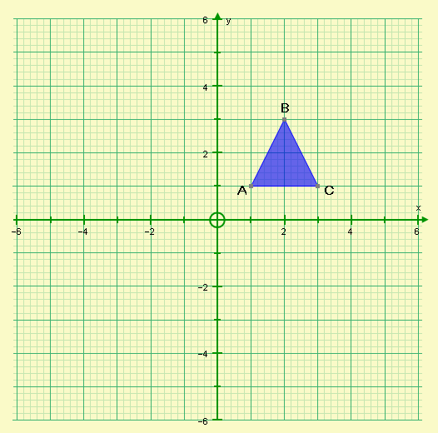

c) Describe the single transformation that will map triangle ABC onto triangle A’’B’’C’’

(3)

x

2. Trapezia A and B are similar.
NOT TO SCALE

yº

30º

15cm

10cm

x
3cm

Calculate the values of:

- x

- y

(4)

3. Calculate the value of x in the diagram below:
NOT TO SCALE

x
5cm

5cm
2cm
6cm

(3)

4. Find the value of a in the diagram below:
NOT TO SCALE

12cm

4cm

3cm
a

(4)

5. x, y and z represent lengths in the following formulae. By considering dimensions, which of the formulae below could represent length (L), area (A) or volume (V)?

x+y+z | xyz | 3xy | x(y+z) | 4$π$x² | y²+2z | $$\frac{x+y}{z}$$

(6)

6. Find the missing angles in the diagrams below, giving reasons for your answers:

NOT TO SCALE
a)

a
50º

O

a = ……….

because

(2)

b)
NOT TO SCALE
50º

O
b

c

b = ……….

because

(2)

c = ……….

because

(2)

NOT TO SCALE
c)

e
d
20º
g

15º
f

d = ……….

because

(2)

e = ……….

because

(2)

f = ……….

because

(2)

g = ……….

because

(2)

7. Find the missing side indicated in each the following triangles, giving your answer to a sensible degree of accuracy:
NOT TO SCALE

a)

CALCULATORS ARE ALLOWED FOR QUESTIONS
7 - 10

12cm

a

30º

(3)
b)

b

40º

10cm
(3)

c)

c

30º
40º
12m

(3)

d)

8cm

50º

d

(3)

e)
50º

5m
e

(3)
f)
4cm

f

70º

(3)

8. Find the missing angle indicated in each the following triangles, giving your answer to a sensible degree of accuracy:
NOT TO SCALE

a)

12cm

8cm

a

(3)
b)

5cm
9cm

b

(3)

c)

80cm

c
30º
1.2m

(3)

d)

8cm

d

4cm

(3)
9. A step ladder can only be safely climbed if the angle of elevation to the ground is less than 75º.
How far away from a wall must the ladder be to safely reach 3m above the ground?

(4)

10. A ship sails from Harbour due East for 4km. It then sails due South for a further 6km.
Calculate the bearing of the ship from the harbour.

(4)

Did you ‘Make the Grade’ ?

Skill | Qu | ☺ | ☹
I can transform shapes using reflections | 1a
I can transform shapes using translations | 1b
I can describe transformations | 1c
I can find missing sides in simple similar shapes | 2a
I can find missing sides in more complex similar shapes | 3,4
I can find missing angles in similar shapes | 2b
I can use dimensions to identify types of formulae | 5
I can solve circle problems using angle properties | 6
I can state the circle properties correctly | 6
I can find missing sides using trigonometry in simple cases | 7a - d
I can find missing sides using trigonometry in harder cases | 7e - f
I can find missing angles using trigonometry in simple cases | 8a,b
I can find missing angles using trigonometry in harder cases | 8c - d
I can solve problems using trigonometry | 9,10

☺ Yippee!! - I got all the questions correct.
☹ I made mistakes and need to practise this topic more.

Top 3 topics I need to revise are

If your score is:

51 – 73 - Well done. You are working at grade B with your shape and space skills.

26 – 50 - Promising work – make sure you ask for help and revise the topics that you had difficulty with. You can still get that B !!!

0 – 25 - Serious revision and help is needed. Sort it out now.
Don’t wait any longer

