MAKE THE GRADE
SHAPE, SPACE & MEASURES, SPACE AND MEASURES
Questions
1 - 7

1.a) Calculate the area of the following sectors, leaving your
answer in terms of $π$:


(i) $A=\frac{1}{4}×({\text{π2}}^{2})={\text{π cm}}^{2}$
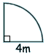

2cm

ANSWERS  = 1 mark

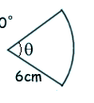
$$θ={\text{72}}^{∘}$$
$$A=\frac{\text{72}}{\text{360}}×({\text{π5}}^{2})=\frac{\text{25π}}{5}=5π{\text{ cm}}^{2}$$


(ii)

5cm



(iii)
$$A=\frac{\text{315}}{\text{360}}×({\text{π6}}^{2})=\frac{7}{8}×\text{36}π=\frac{\text{63}π}{2}{\text{cm}}^{2}$$
45º
6cm

(6)
b) Find the length of the arc in each case, leaving your

answer in terms of $π$:
- arc length = $\frac{1}{4}×(\text{π4})=\text{π cm}$



- $$\text{arc length}=\frac{\text{72}}{\text{360}}×(\text{π10})=\frac{\text{10π}}{5}=2π\text{ cm}$$



- $$\text{arc length}=\frac{\text{315}}{\text{360}}×(\text{π12})=\frac{7}{8}×\text{12}π=\frac{\text{21}π}{2}\text{cm}$$
(6)
2.. a) Enlarge triangle ABC by a factor of -1·5, centre (0,0).
Label the image DEF.

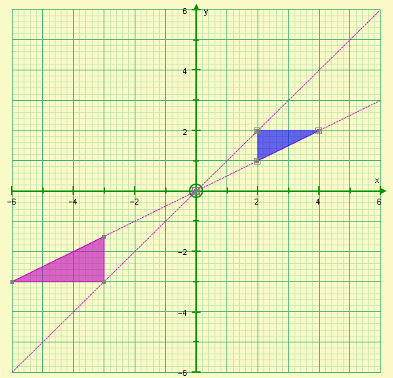
B
C
D
E
F
A
 construction lines
 vertices at the correct places
 correct labels for D,E and F
(3)
b) How many times bigger is the area of triangle DEF than the triangle of ABC?


(1.5)² = 2.25
(2)
3.
15cm
10cm

A

B

Cones A and B are similar.
The volume of cone A is 400cm³.
Find the volume of cone B.

Scale factor = $\frac{\text{15}}{\text{10}}=\frac{3}{2}$ so $V_{B}=(\frac{3}{2})^{3}×\text{400=}$$\frac{\text{27}}{8}×\text{400 }=\text{ 27}×{\text{50 =1350cm}}^{3}$ (3)




4. In the following diagrams, are the two triangles congruent? Justify your answers in each case.
NOT TO SCALE

a)
B
D

35º
60º
F

60º

35º
85º
85º
A
C
E

NO – triangles are not congruent. They are similar because they satisfy the AAA condition but not congruent.

D
b)
B

35º
60º
E
60º
4cm

35º
A
C
F
4cm


AC = DF (side) Triangles ABC and DEF are
$\overset{}{B\overset{}{A}}\text{C=E}\overset{}{D}F$ (angle) congruent because they

$\overset{}{C\overset{}{B}}\text{A=}\overset{}{F\overset{}{E}}D$ (angle) satisfy the AAS condition


c)
B
D
4cm

$\overset{}{C\overset{}{B}}\text{A=}\overset{}{F\overset{}{E}}D$ (angle)

AC = DF (side)
AB = DE (side)

60º
F
6cm
6cm


60º
A
C
4cm
E



Triangles ABC and DEF are not congruent because ASS is not a condition for congruency.
(9)

5.
C
NOT TO SCALE

D

B

60º
45º
A
E

In the diagram above, BÂD = 60º and BÂE = 45º. Find, giving reasons for your answer:

a) $A\overset{}{D}B$ = 45º



Reason: The Alternate Segment Theorem

b) $D\overset{}{C}B$ = 120º


Reason: The sum of the opposite angles in a cyclic quadrilateral is 180º


c) $C\overset{}{D}A$= 45º + 30º = 75º


Reason: Base angles in an isosceles triangle are equal.


(6)

- a) On the axes below, sketch the graphs of:

i) y = sinx

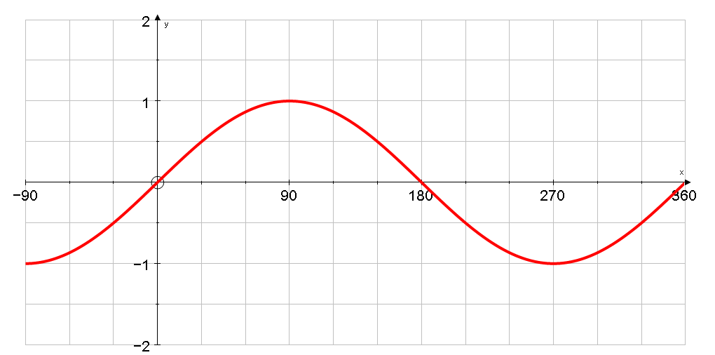
 for correct period
 for correct max and min

ii) y= tanx

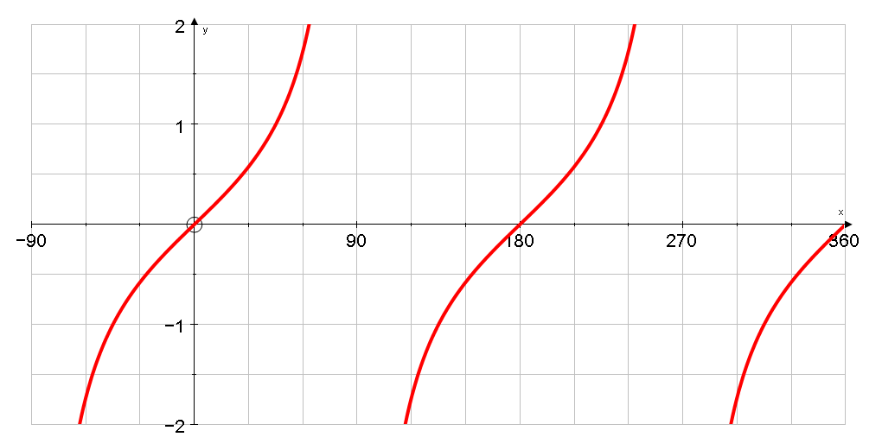
 for correct period
 for asymptotes

b) i) On the axes below, sketch the graph of y= cosx

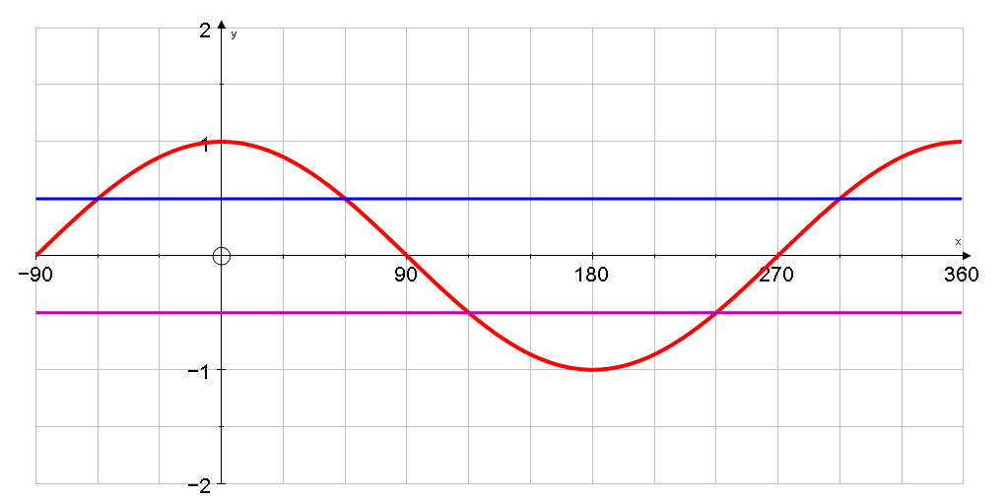
 for correct period
 for correct max and min

ii) Using your graph and cos60° = 0·5, solve the following equations in the range 0°<x<360°:

cosx = 0·5 cosx = -0·5

x = 60°, 360°- 60° x = 180°-60°, 180°+ 60°




x = 60°, 300° x = 120°, 240° (10)
- Find the value of x in the following triangles:
NOTE

Calculators are now allowed

NOT TO SCALE
i)
70º

x

30º
4cm
 sine rule


$$\frac{x}{\text{sin30}}=\frac{4}{\text{sin70}} ⇒\text{ x }=\frac{\text{4sin30}}{\text{sin70}}=2\text{.}\text{1cm }(\text{to 1dp})$$

 sine rule
ii)
$$\begin{aligned}\frac{x}{\text{sin30}}=\frac{8}{\text{sin40}} \\ \\ x=\frac{\text{8sin30}}{\text{sin40}}=6\text{.}\text{2cm }(\text{to 1dp})\end{aligned}$$
30º



8cm

110º
40º
x
 spotting cosine rule
 for substituting 5,13,120º and x correctly

$\begin{aligned}x=5^{2}+{\text{13}}^{2}\text{- }(\text{2x5x13xcos120}) \\ x=\text{25 }+\text{ 169 }+\text{ 65} \\ x=\text{ 259} \\ \text{x }=\text{ 16}\text{.}\text{1cm}\end{aligned}$$\begin{aligned}x=5^{2}+{\text{13}}^{2}\text{- }(\text{2x5x13xcos120}) \\ x=\text{25 }+\text{ 169 }+\text{ 65} \\ x=\text{ 259} \\ \text{x }=\text{ 16}\text{.}\text{1cm}\end{aligned}$

iii)



x
13cm

120º

5cm

(10)

- a) Find the value of x in the following triangles:
NOT TO SCALE

i)
x
12cm
4cm

 spotting cosine rule
 for substituting 4,12,14 and x correctly

14cm

$\begin{aligned}\text{14}={\text{12}}^{2}+4^{2}\text{- }(2×\text{12}×4×\text{cosx}) \\ \text{196}=\text{144}+\text{ 16 - 96cosx} \\ \text{96cosx}=\text{ 160 - 196 }=\text{ -36} \\ \text{cosx }=\frac{\text{-36}}{\text{96}} \\ x={\text{112}}^{⊗∘}\end{aligned}$
 sine rule



$\begin{aligned}\frac{\text{sinx}}{8}=\frac{\text{sin50}}{\text{12}} \\ \\ \text{sinx }=\frac{\text{8sin50}}{\text{12}}=0\text{.}\text{510696295}\text{.}\text{.}\text{.} \\ x=\text{30}\text{.}7^{∘}(\text{to 1dp})\end{aligned}$$\begin{aligned}\frac{\text{sinx}}{8}=\frac{\text{sin50}}{\text{12}} \\ \\ \text{sinx }=\frac{\text{8sin50}}{\text{12}}=0\text{.}\text{510696295}\text{.}\text{.}\text{.} \\ x=\text{30}\text{.}7^{∘}(\text{to 1dp})\end{aligned}$
ii)
x



12cm



50º
8cm

b) Find the possible values of y in the following triangles:
$\begin{aligned}\frac{\text{sinx}}{\text{12}}=\frac{\text{sin40}}{8} \\ \\ \text{sinx }=\frac{\text{12sin40}}{8}=0\text{.}\text{964181414}\text{.}\text{.}\text{.} \\ x=\text{74}\text{.}6^{∘}(\text{to 1dp}) \\ \\ \text{or x }={\text{ 180}}^{∘}\text{- 74}\text{.}6^{∘}=\text{105}\text{.}4^{∘}\end{aligned}$$\begin{aligned}\frac{\text{sinx}}{\text{12}}=\frac{\text{sin40}}{8} \\ \\ \text{sinx }=\frac{\text{12sin40}}{8}=0\text{.}\text{964181414}\text{.}\text{.}\text{.} \\ x=\text{74}\text{.}6^{∘}(\text{to 1dp}) \\ \\ \text{or x }={\text{ 180}}^{∘}\text{- 74}\text{.}6^{∘}=\text{105}\text{.}4^{∘}\end{aligned}$
 sine rule




8cm
12cm



x
(11)
40º
9. Calculate the area of the following triangles:

a) An equilateral triangle of side 5cm

$$\text{A }=\frac{1}{2}×5×5×{\text{sin60}}^{∘}\text{=10}\text{.}{\text{8cm}}^{2}(\text{to 3sf})$$


b)
40º
8cm


$$\text{A }=\frac{1}{2}×8×8×{\text{sin40}}^{∘}\text{=20}\text{.}{\text{6cm}}^{2}(\text{to 3sf})$$


c)

7cm
6cm

30º

8cm


$$\text{A }=\frac{1}{2}×8×7×{\text{sin30}}^{∘}{\text{=14cm}}^{2}$$


(6)

10. Find the area of the shaded region.



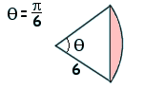
8cm
$$\begin{aligned}(\frac{\text{55}}{\text{360}}×π×8^{2})−(\frac{1}{2}\text{x8x8xsin55}) \\ \\ 4\text{.}{\text{5cm}}^{2}(\text{to 2sf})\end{aligned}$$


55º


(4)

11. Will Pam’s snooker cue of length 1.5m fit inside her cupboard?

1·2m

60cm
70cm

120
h

Base:
60
x

70

$$\sqrt{\text{8500}}$$

$$\begin{aligned}x^{2}{\text{=60}}^{2}{\text{+70}}^{2} \\ x^{2}\text{=3600 }+\text{ 4900} \\ x^{2}\text{=8500} \\ x=\sqrt{\text{8500}}\end{aligned}$$
$$\begin{aligned}h^{2}{\text{=120}}^{2}+(\sqrt{\text{8500}})^{2} \\ h^{2}\text{=14400 }+\text{ 8500} \\ h^{2}\text{=22900} \\ h=\sqrt{\text{22900}}\text{=151}\text{.}\text{3274595}\text{.}\text{.}\text{.}\end{aligned}$$






YES – the cue will fit inside her wardrobe
(5)

12. Calculate the distance between (1, -2, 5) and (-1, -3, 3)

$$\begin{aligned}\text{distance }=\sqrt{(\text{1--1})^{2}+(\text{-2--3})^{2}+(\text{5-3})^{2}} \\ \sqrt{2^{2}+1^{2}+2^{2}}=\sqrt{9}=3\end{aligned}$$




(3)

- Chocolate balls are made by pouring molten chocolate into spherical moulds of diameter 4cm. How many can be made from 5 litres of molten chocolate?

Volume of one ball = $\frac{4}{3}×π×2^{3}$=$\frac{\text{32}π}{3}{\text{cm}}^{3}$


$\begin{aligned}\text{5000 }÷(\frac{\text{32π}}{3})=\text{ 149}\text{.}\text{20777} \\ \\ \text{149 balls}\end{aligned}$



(3)

- a) How much ice cream can be fill the following cone?
12cm

$$V=\frac{1}{3}×π×6^{2}×{\text{8= 302cm}}^{3}(\text{to 3sf})$$



8cm

(2)
b) Find the curved surface area of the cone.

$$\text{Curved SA }=\text{ πrl}$$

6cm

8cm
l


Slant height (l) = 10cm (Pythagorean Triple)

$$\text{Curved SA }=\text{ πr l }=\text{ π }×6×\text{10 }={\text{ 189cm}}^{2}(\text{to 3sf})$$



(3)

15. Which is greater – the total surface area of a hemisphere, radius 5cm or the total surface area of a cone, diameter 6cm, sloping edge 5cm?



$\text{Total SA of hemipshere }=\frac{\text{4x}π{\text{x5}}^{2}}{2}+(π{\text{x5}}^{2}){\text{= 236cm}}^{3}(\text{to 3sf})$



$$\text{Total SA of cone }=(π\text{x3x5})+(π{\text{x5}}^{2}){\text{= 126cm}}^{3}(\text{to 3sf})$$

The Surface Area of the hemisphere is greater


(7)

16. Find the radius of a sphere with a volume of 500cm³.


$$\text{500}=\frac{4}{3}×π×r^{3} ⇒{\text{ r}}^{3}=\frac{\text{1500}}{4π} ⇒\text{ r }=\sqrt[3]{\text{119}\text{.}\text{3662073}\text{.}\text{.}}=4\text{.}\text{9cm }(\text{to 1dp})$$



(4)

Did you ‘Make the Grade’?
Skill | Qu | ☺ | ☹
I can calculate the area of sectors | 1a, (10)
I can calculate the length of circular arcs | 1b
I can enlarge shapes using negative scale factors | 2a
I understand the effect of enlargements on area and volumes | 2b, 3
I understand and use the conditions for congruent triangles | 4
I can solve circle problems using angle properties, in particular the Alternate Segment Theorem. | 5
I can sketch the graphs of sine, cosine and tangent | 6a, bi
I can solve simple trigonometrical equations | 6bii
I can solve problems using the sine rule | 7i,7ii, 8ii, 8iii
I can solve problems using the cosine rule | 7iii, 8i
I can find the area of any triangle | 9, (10)
I can solve Pythagoras problems in 2D and 3D | 11, 12,14b
I understand and use the formula for the volume of a sphere | 13,16
I understand and use the formula for the surface area of a sphere | 15
I understand and use the formula for the volume of a cone | 14a
I understand and use the formula for the surface area of a cone | 14b,15

☺ Yippee!! - I got all the questions correct.
☹ I made mistakes and need to practise this topic more.

Top 3 topics I need to revise are

If your score is:

76 - 103 - Well done. You are definitely working at grade A with your shape, space and measures skills. Bring on the A*!
40 – 75 - Promising work – make sure you ask for help and revise the topics that you had difficulty with. You can still get that A !!!
0 – 39 - Serious revision and help is needed if you are going to get that A. Sort it out now. Don’t wait any longer

