MAKE THE GRADE

HANDLING DATA
ANSWERS ❶ = 1 mark

1. Using the Box and Whisker Plot, complete the table:

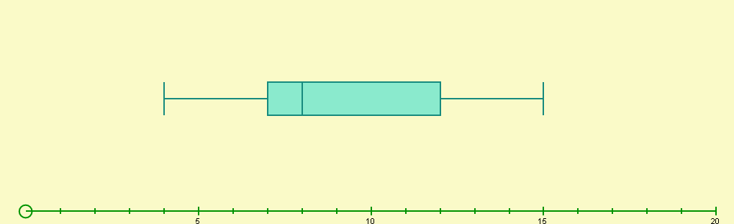

Minimum  value | Lower Quartile | Median | Interquartile  Range | Upper Quartile | Maximum  value | Range
4 | 7 | 8 | 5 | 12 | 15 | 11  ❶
❶
❶
❶
❶
(5)
2. Bob and Mary are driving instructors. The number of minor errors made by their students in the driving test are shown in the box and whisker plots below:

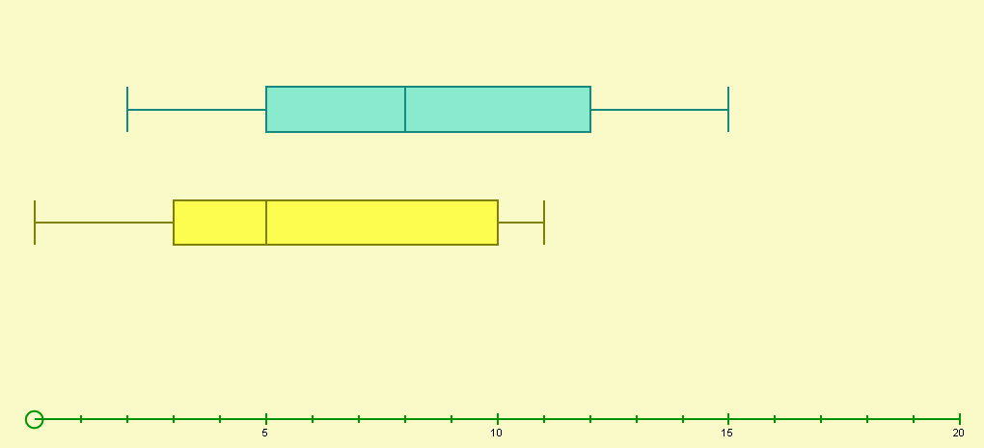
Bob
Mary

a) Who is the best driving instructor? Give reasons for your answer.
❶
Mary because:
- her students make on average fewer minor mistakes (lower median)
- even though the interquartile ranges are the same (7), her range (11) is lower than Bob’s (13) meaning there is a smaller spread in her results. Mary’s average is more reliable as a measure of performance
(or similar - ❶ for mentioning average and ❶ for describing the ‘spread’)
(3)
b) What percentage of Mary’s students had ten or more minor errors?
25% (1)
❶
3. Match the frequency diagram with the correct Box and Whisker plot.
Complete the missing Box and whisker plot.
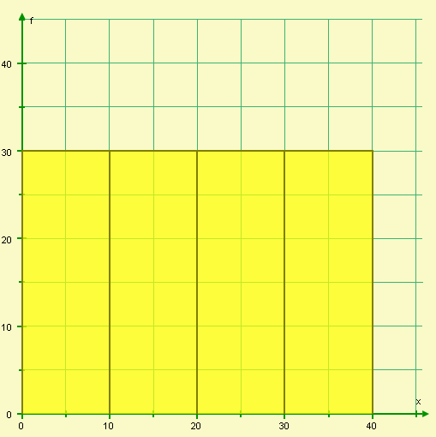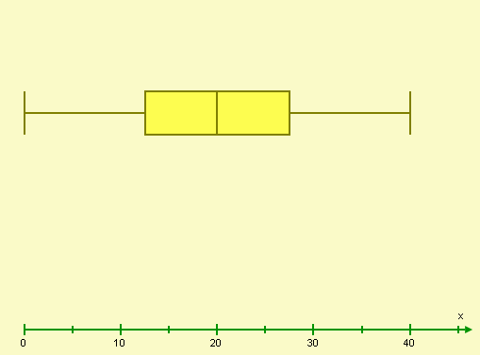
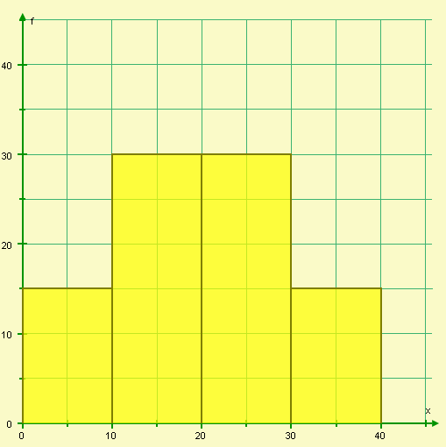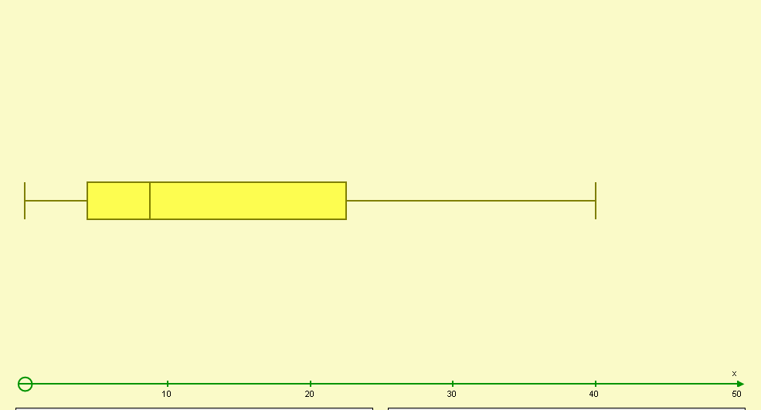
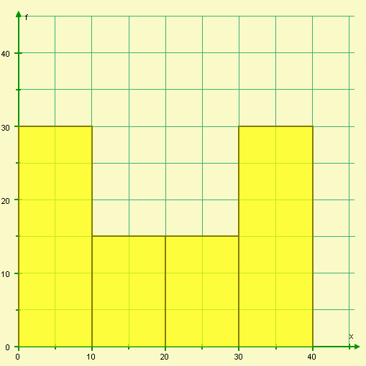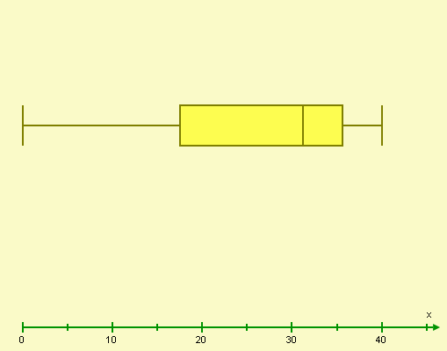

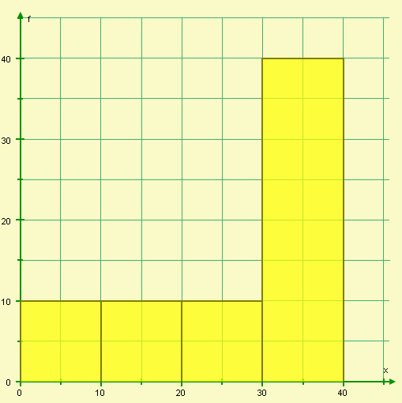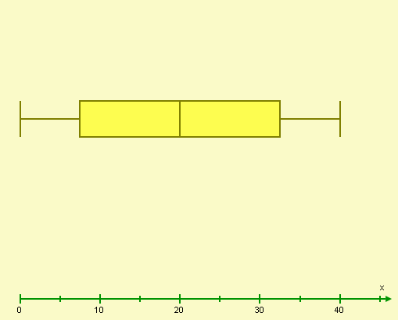
❶ for each correct match – total 6 + ❶ for correct missing box and whisker plot
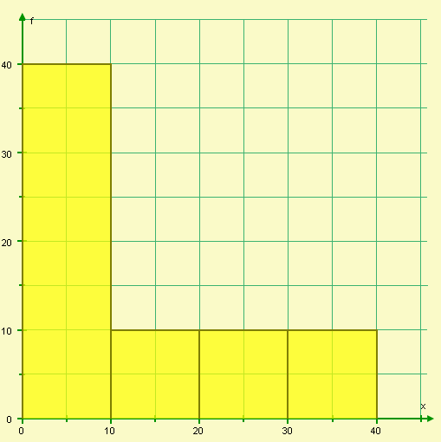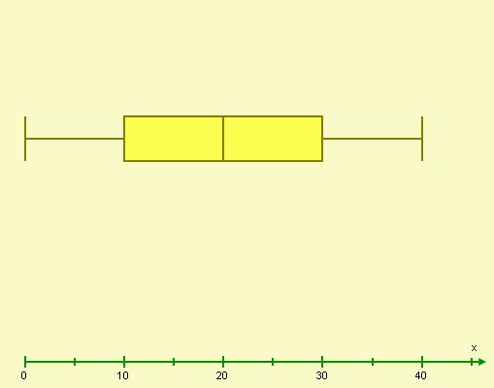
(7)

4. The table below shows the scores of students on the Non-calculator GCSE paper.
Score(x) | Frequency | Cumulative Frequency
0<x≤10 | 2 | 2
10<x≤20 | 3 | 5
20<x≤30 | 5 | 10
30<x≤40 | 15 | 25
40<x≤50 | 20 | 45  ❶ attempt to add frequencies  ❶ correct numbers
50<x≤60 | 15 | 60
60<x≤70 | 5 | 65
70<x≤80 | 8 | 73
80<x≤90 | 5 | 78
90<x≤100 | 2 | 80
- Complete the cumulative frequency column. (2)

b) Draw a cumulative frequency curve for the results (4)
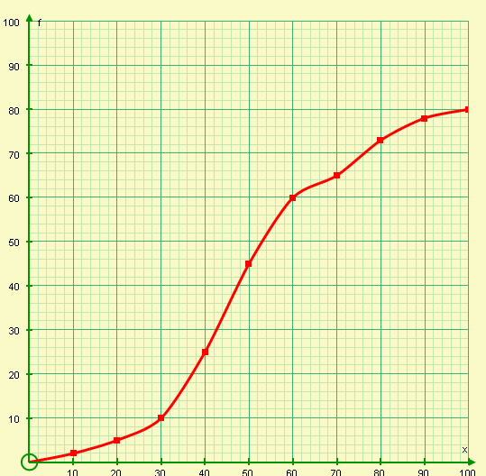
16
Median
Q1
Q3
❶ plotting at the upper limits
❶ plotting the cumulative frequencies
❶ axes labelled correctly
❶smooth curve
Score
cf
❶ line drawn at cf = 40
❶ 48 (±1)

- Using your graph, find the median score for the Non-calculator paper.
48 (±1) (2)
❶ line drawn
at score = 52
❶ 32
- If the minimum score needed for a grade C is 52, using your graph, how many students achieved a grade C or higher?
80 – 48 = 32 (2)
  - 20% of the students achieved a grade B. Using your graph, what is the minimum score needed to achieve a grade B?
❶
20% of 80 = 16 Minimum score = 68 (2)
❶

- The Box and whisker plot shows the scores of the students on the Calculator paper. Using your cumulative frequency curve, draw the box and whisker plot for the Non-calculator paper scores.

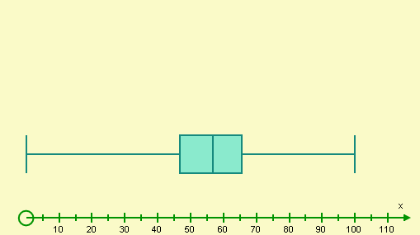
❶
❶
❶
❶

(4)

- Using the box and whisker plots, comment how students have preformed on the non-calculator and calculator papers.

- Students do better on the calculator paper – higher average (median)
❶

- The interquartile range is smaller for the calculator paper which means the spread is smaller. The average is more reliable as a measure of performance for the calculator paper.
❶
(2)
5. Lance is drawing a cumulative frequency curve.
Length | Frequency
1<x≤2 | 0
2<x≤3 | 5
3<x≤4 | 15
4<x≤5 | 20
5<x≤6 | 25
6<x≤7 | 18
7<x≤8 | 10
8<x≤9 | 5
9<x≤10 | 3
10<x≤11 | 2
11<x≤12 | 1
Is he correct? Give at least two reasons for your answer.
NO
❶
- He has plotted frequency and not cumulative frequency
❶
❶
- He has plotted at the lower bound rather than the upper bound (3)

6. Using the cumulative frequency curve below, complete the table:

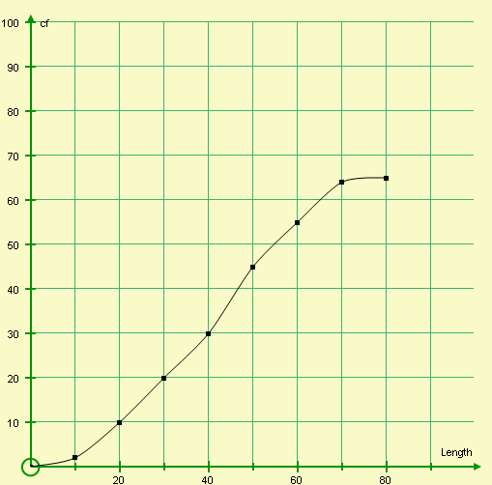
65
❶ correct class intervals
+
❶ two correct frequencies or
❷ five correct frequencies or
❸ all frequencies correct

Length (L) | 0<L≤10 | 10<L≤20 | 20<L≤30 | 30<L≤40 | 40<L≤50 | 50<L≤60 | 60<L≤70 | 70<L≤80
Frequency | 2 | 8 | 10 | 10 | 15 | 10 | 9 | 1

(4)
7. The number of detentions Phil receives each week for poor behaviour are shown below:

Week | Detentions
1 | 3
2 | 4
3 | 5
4 | 1
5 | 2
6 | 3
7 | 5
8 | 1

- Calculate 4 point moving averages for this data.

$\begin{aligned}M_{1}=\frac{3+4+5+1}{4}=\frac{\text{13}}{4}=3\frac{1}{4}\begin{matrix} & & \end{matrix}M_{2}=\frac{4+5+1+2}{4}=3 \\ M_{3}=\frac{5+1+2+3}{4}=\frac{\text{11}}{4}=2\frac{3}{4}\begin{matrix} & & \end{matrix}M_{4}=\frac{1+2+3+5}{4}=\frac{\text{11}}{4}=2\frac{3}{4} \\ M_{5}=\frac{2+3+5+1}{4}=\frac{\text{11}}{4}=2\frac{3}{4}\end{aligned}$ (5)
❶
❶
❶
❶
❶

b) Plot your 4 point moving averages on the time series below:

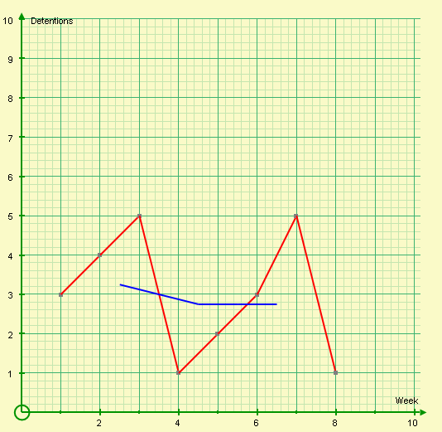
❶ plotting at the midpoint of each group of 4
❶ straight line

(2)
- Using your graph, comment on the trend of Phil’s behaviour
It is getting better (fewer detentions) ❶
(1)
- Using the trend, estimate the number of detentions Phil will receive in Week 9.
2 or 3 ❶
(1)
8. Bob has a tube of ‘Millions’ (small coloured sweets). He is counting the sweets to see if there are millions if sweets in his packet. He records the colour of the first ten sweets:

Sweet | 1 | 2 | 3 | 4 | 5 | 6 | 7 | 8 | 9 | 10
Colour | Blue | Yellow | Blue | Yellow | Red | Blue | Blue | Blue | Red | Blue

Bob makes the following statements:
    - There are only blue, yellow and red sweets in my packet
    - There are more blue sweets than any other coloured sweet in my packet
    - The next sweet out will highly likely be blue or red
❶ for each NO
❶ for each correct statement

Do you agree with Bob’s statements? Explain your answers.

NO – There might be other colours. Bob has only picked blue, red and yellow so far.

NO – So far Bob has picked more blue ones. This doesn’t mean there are more blue ones in total

NO – I don’t know how many of each colour there are in the packet
(6)
9 . Helen has two regular dice. She rolls each one 42 times and records the results.

Number | Die 1 frequency | Die 2 frequency
1 | 5 | 2
2 | 7 | 7
3 | 7 | 6
4 | 5 | 7
5 | 9 | 8
6 | 9 | 12

- Helen thinks one of her dice is biased. Do you agree? Give reasons for your answer.
❶
Yes – Die 2 could be.

The probability of each number occurring is $\frac{1}{6}$ so each number should occur around 42 ÷ 6 = 7 times. Numbers 1 and 6 on die 2 don’t fit this pattern
❶
(2)
10. The probability of a spinner landing on a two is 0∙2. If the spinner is spun 150 times, how many times would you estimate not to get a two?
❶
p(not 2) = 0∙8 0∙8 x 150 = $\frac{8}{\text{10}}x\text{150}=8x\text{15}=\text{120}$
❶
(2)
11. Meryl has been revising hard using past papers and ‘Make the Grade’ assessments. She has worked out the probability of passing the calculator and non-calculator papers (getting at least a grade C). Complete the following probability tree diagram:
Pass $\frac{5}{7}$
Pass Pass

Pass Fail

❶
Fail Pass

Fail Fail (5)

Pass $\frac{3}{4}$❶
Fail $\frac{2}{7}$❶

Pass $\frac{5}{7}$❶

Fail $\frac{1}{4}$

What’s your probability of passing both papers?
DON’T LEAVE IT TO CHANCE!
Fail $\frac{2}{7}$❶

CALCULATOR PAPER
NON- CALCULATOR PAPER

Did you ‘Make the Grade’ ?

Skill | Qu | ☺ | ☹
I can draw box and whisker plots | 1
I can compare two sets of data using box and whisker plots | 2,4g
I can match frequency diagrams with the correct box and whisker plot | 3
I can calculate the cumulative frequency | 4a,6
I can draw a cumulative frequency curve | 4b,5
I can use a cumulative frequency curve to find the median | 4c
I can use a cumulative frequency curve to find the upper and lower quartiles | 4f
I can use a cumulative frequency curve to find estimates | 4d-e
I can calculate moving averages | 7a
I can plot moving averages | 7b
I can use trends to make predictions | 7c-d
I can interpret relative frequencies | 8,9
I can use theoretical probabilities to make estimates | 10
I can complete probability tree diagrams correctly | 11

☺ Yippee!! - I got all the questions correct.
☹ I made mistakes and need to practise this topic more.

Top 3 topics I need to revise are

If your score is:

45 – 65 - Well done. You are working at grade B with your handling data skills.

21 – 44 - Promising work – make sure you ask for help and revise the topics that you had difficulty with. You can still get that B !!!

0 – 20 - Serious revision and help is needed. Sort it out now.
Don’t wait any longer

