

GCSE in Mathematics B
Modular 2544
Unit 3
Number, Algebra, Shape Space and Measures 1
Practice Paper G
Higher
(Calculator and Non – Calculator)
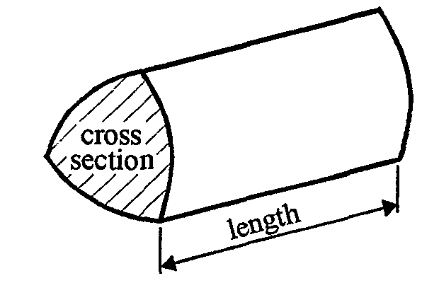
EDEXCEL
GCSE Mathematics 2540/2544
Formulae sheet — Higher tier

Volume of prism = area of cross-section  length

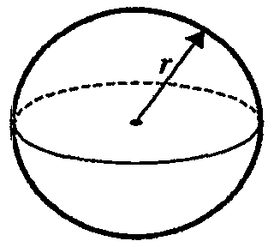
Volume of sphere = $\frac{4}{3}$ r³

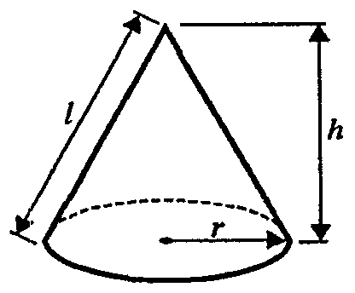
Surface area of sphere = 4 r²

Volume of cone = $\frac{4}{3}$ r²h
Curved surface area of cone =  rl
A
a
b
c
C
B

In any triangle ABC

Sine Rule: $\frac{a}{\text{sin}A}$ = $\frac{b}{\text{sin}B}$ = $\frac{c}{\text{sin}C}$
Cosine Rule: a² = b² + c² –2bc cos A
Area of a triangle = $\frac{1}{2}$ ab sin C
The Quadratic Equation
The solutions of ax² + bx + c = 0, where a  0, are given by x = $\frac{−b±\sqrt{(b^{2}−4\text{ac})}}{2a}$
Higher – Section A – Calculator

13 m
5 m
Diagram NOT accurately drawn
1.

9 cm

Work out the area of the shape.

……..………….m²
(Total 3 marks)

2. Here are the first five terms of an arithmetic sequence.

7 11 15 19 23

Find, in terms of n, an expression for the nth term of this sequence.

………………
(Total 2 marks)

3. (a) Expand 4(x – 3)

……………….
(1)
(b) Factorise fully 15y + 50

…………….
(1)
(Total 2 marks)

4. Draw the graph of y = 5x − 2 on the grid below.

(Total 3 marks)

5.
40 cm
30 cm
20 cm

The diagram shows a solid cuboid.
The cuboid is made of wood.
The wood has a density of 0.35 g/cm³.

Work out the mass of the cuboid.
Give your answer in kilograms

……………………kilograms
(Total 4 marks)

7. (i) Write 0.053 in standard form.

......................
(1)

(ii) Write 672  10⁸ in standard form.

.......................
(1)
(Total 2 marks)

8. (a) Simplify fully 5(2x – 3) + 4(x – 1)

…........................
(2)

(b) Expand and simplify (3x + 5)(2x – 7)

…........................
(2)

(c) Simplify fully

…........................
(2)
(Total 6 marks)

9. Show that = a2 + b2

………………..
(Total 3 marks)

Total: 25 marks
Higher –Section B – Non-Calculator

1. Work out

38.4  0.16

You must show all your working.

………………..
(Total 3 marks)

2. Using the information that 17  19 = 323

write down the value of

(i) 0.17  1.9

.................................
(1)

(ii) 323  0.019

.................................
(1)
(Total 2 marks)

3. Expand and simplify 3(2x − 1) − 2(2x − 3)

…..…….……
(Total 2 marks)

4. Simplify fully:

(i) 7⁶  7²

…........................

(ii)

…........................
(Total 3 marks)

5. Work out (9.8  10⁸)  (2  10²)
Give your answer in standard form.

…………………..…
(Total 2 marks)

6. Factorise x + 4x – 45

…………………..
(Total 2 marks)
7.
Diagram NOT accurately drawn
B and C are points on a circle, centre O.
AB and AC are tangents to the circle.
Angle BOA = 72°.
Work out the size of angle BAC.
Give a reason for each stage in your working.

............................°
(Total 3 marks)

8. Fred runs 200 meters in 21.2 seconds.

Work out Fred’s average speed.
Give your answer in kilometres per hour.

…………………………….. meters per second
(Total 3 marks)

9. The number 1104 can be written as 3  2^{c}  d, where c is a whole number and d is a prime number.

Work out the value of c and the value of d.

c = ……….…………

d = ……….…………

(Total 2 marks)

10. Simplify fully

……………………
(Total 3 marks)

Total 25 marks

1. 81 cm²
2. 4n + 3
3. (a) 4x – 12
(b) 5(3y + 10)
4. (a) 2357 → 2400
(b) 0.003745 → 0.0037
5. Correct Graph
6. 8.4 kg
7. (a) 5.3  10⁻²
(b) 6.72  10¹⁰
8. (a) 14x – 19
(b) 6x² – 11x – 35
(c) 2(k + 8)
9. Correct proof
Section B
1. 240
2. (i) 0.323
(ii) 17000
3. 2x + 3
4. (i) 7⁴
(ii) 7⁸
5. 4.9  10⁶
6. (x + 9)(x – 5)
7. 36º; Angle between tangent and radius is 90º; Tangents from a point are equal
8. 34.0 km/h
9. c = 4 ; d = 23
10.

