

GCSE in Mathematics B
Modular 2544
Unit 3
Number, Algebra, Shape Space and Measures 1
Practice Paper F
Higher
(Calculator and Non – Calculator)
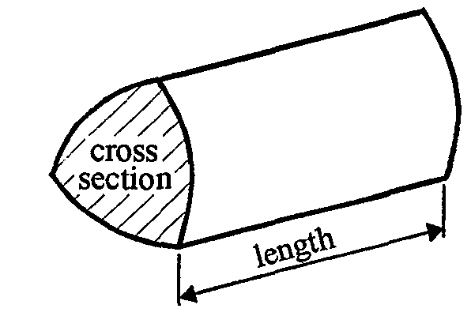
EDEXCEL
GCSE Mathematics 2540/2544
Formulae sheet — Higher tier

Volume of prism = area of cross-section  length

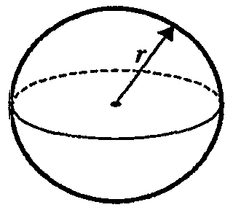
Volume of sphere = $\frac{4}{3}$ r³

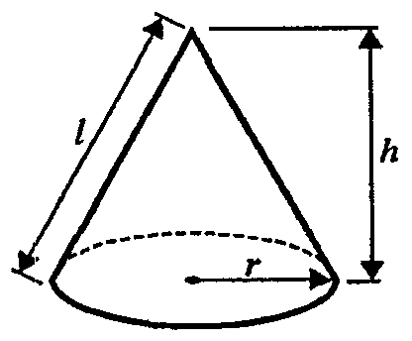
Surface area of sphere = 4 r²

Volume of cone = $\frac{4}{3}$ r²h
Curved surface area of cone =  rl
A
a
b
c
C
B

In any triangle ABC

Sine Rule: $\frac{a}{\text{sin}A}$ = $\frac{b}{\text{sin}B}$ = $\frac{c}{\text{sin}C}$
Cosine Rule: a² = b² + c² –2bc cos A
Area of a triangle = $\frac{1}{2}$ ab sin C
The Quadratic Equation
The solutions of ax² + bx + c = 0, where a  0, are given by x = $\frac{−b±\sqrt{(b^{2}−4\text{ac})}}{2a}$
Higher – Section A – Calculator

1. Use your calculator to work out the value of
$\frac{\sqrt{\left(1\text{.}3^{2} + 4\text{.}2\right)}}{5\text{.}1 − 2\text{.}\text{02}}$
Write down all the figures on your calculator display.

……..………….………..
(Total 2 marks)

2. A car travels at 30 miles per hour.
Change 30 miles per hour to kilometres per hour.

.......................... kilometres per hour
(Total 2 marks)

3. The point A has co-ordinates (−1, −2, −5).
The point B has co-ordinates (3, 4, 7).

Find the co-ordinates of P the mid-point of AB.

(…..…, …..…, …..…)
(Total 2 marks)

4. (a) Write 2357 correct to 2 significant figures.

.................................
(1)

(b) Write 0.003745 correct to 2 significant figures.

.................................
(1)
(Total 2 marks)

5.
A

Diagram NOT accurately drawn

70º

B

The bearing of A from B is 070º.

Work out the bearing of B from A.

………….º
(Total 2 marks)

6.
7 m
12 m
2 m
6 m
3 m
2 m
Diagram NOT accurately drawn

The diagram shows a paved surface.
All the corners are right angles.
Work out the area of the paved surface.

…………...................m²
(Total 3 marks)

7. (a) Expand and simplify 4(x + 3) + 3(2x – 5)

……………….
(2)
(b) Multiply out and simplify

(x + 3)(x − 2)

…………...................
(2)
(Total 4 marks)

8. p is a prime number not equal to 7

(a) Write down the Highest Common Factor (HCF) of

49p and 7p²

…………...................
(1)
x and y are different prime numbers.

(b) (i) Write down the Highest Common Factors (HCF) of the two expressions

x²y xy²

…………...................

(ii) Write down the Lowest Common Multiple (LCM) of the two expressions

x²y xy²

…………...................
(3)
(Total 4 marks)

9. (a) Factorise 3x² +7x – 6

………………
(2)
- Write as a single fraction

…………………
(2)
(Total 4 marks)

Total: 25 marks
Higher –Section B – Non-Calculator

1. Work out 34.2  0.53
You must show all you working.

…………………..
(Total 3 marks)

2. Daniel leaves his house at 07 00.
He drives 87 miles to work.
He drives at an average speed of 36 miles per hour.
At what time does Daniel arrive at work?

…………………………
(Total 3 marks)

3. (a) Complete this table of values for y = 3x + 1.

x | −2 | −1 | 0 | 1 | 2 | 3
y | −5 |  |  | 4 |  | 10

(1)
(b) On the grid below, draw the graph of y = 3x + 1

(2)

(c) Use your graph to find the value of x when y = 6

x = .......................
(1)
(Total 4 marks)

4. (a) Write the number 50 000 000 in standard form.

…..…….……
(1)
(b) Write the number 0.000 082 in standard form.

…..…….……
(1)
(Total 2 marks)

5. (a) Find the value of ${\text{16}}^{\frac{1}{2}}$

…………………..…
(1)
(b) 7⁵  7⁶ = 7³  7^{k}

Find the value of k.

k = …………………..…
(2)
(Total 3 marks)

6.
A
C
B
D
E
82°
y°
119°
74°
x°
Diagram NOT accurately drawn

The diagram shows a quadrilateral ABCD and a straight line CE.
AB is parallel to CE.

(a) Work out the size of the angle marked x°.

………………°
(2)
(b) (i) Work out the size of the angle marked y°.

………………°

(ii) Give a reason for your answer.

…………………………………………………………………………………

…………………………………………………………………………………..
(2)
(Total 4 marks)

7. (a) Factorise x² + x

………………
(1)
(b) Factorise y² − 2y − 35

………………
(2)
(Total 3 marks)

8. Express the recurring decimal as a fraction in its simplest form.

………………
(Total 3 marks)

Total 25 marks

BLANK PAGE
1. $\frac{\sqrt{1\text{.}3^{2} + 4\text{.}2}}{5\text{.}1 −2\text{.}\text{02}} = \frac{\sqrt{5\text{.}\text{89}}}{3\text{.}\text{08}} = \frac{2\text{.}\text{426932}\text{.}\text{.}\text{.}}{3\text{.}\text{08}}$ = 0.787965006
2. 1 mile = 1.6 km
30 mph = 30  1.6 = 48 km per h
3. Midpoint = $\left(\frac{−1 + 3}{2}, \frac{−2 + 4}{2}, \frac{−5 + 7}{2}\right)$ = (1, 1, 1)

4. (a) 2357 → 2400
(b) 0.003745 → 0.0037
5. 250º
6. Area = 14 + 20 + 12 = 66 m²
7 m
12 m
2 m
6 m
3 m
2 m
Diagram NOT accurately drawn
7  2 = 14
10  4 = 40
6  2 = 12

7. (a) 10x – 3
(b) (x + 3)(x − 2) = x² − 2x + 3x − 6 = x² + x − 6
8. (a) 7p
(b) (i) HCF = xy
(ii) LCM = x²y²
9. (a) 3x² + 7x – 6
(b)
Section B
1. 18.126
2. 09 25
3.
x | −2 | −1 | 0 | 1 | 2 | 3
y | (−5) | −2 | 1 | (4) | 7 | (10)

(b) Correct graph
(c) when y = 6, x = 1.6 (accept 1.5 to 1.9)
4. (a) 50000000 = 5  10⁷
(b) 0.000082 = 8.2  10⁻⁵
5. (a) ${\text{16}}^{\frac{1}{2}} = \sqrt{\text{16}}$ = 4
(b) 7⁵  7⁶ = 7³  7^{k}
5 + 6 = 3 + k k = 8
6. (a) 360 − 119 − 74 − 82 = 360 − 275 = 85°
(b) (i) 74°
(ii) alternate angles
7. (a) x² + x = x(x + 1)
(b) y² − 2y − 35 = (y − 7)(y + 5)

8.

