

GCSE in Mathematics B
Modular 2544
Unit 3 Number, Algebra, Shape Space and Measures 1
Practice Paper E
Higher
(Calculator and Non – Calculator)
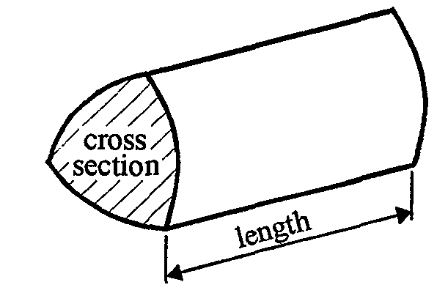
EDEXCEL
GCSE Mathematics 2540/2544
Formulae sheet — Higher tier

Volume of prism = area of cross-section  length

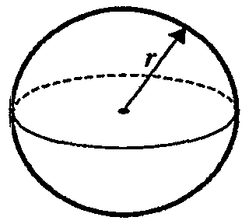
Volume of sphere = $\frac{4}{3}$ r³

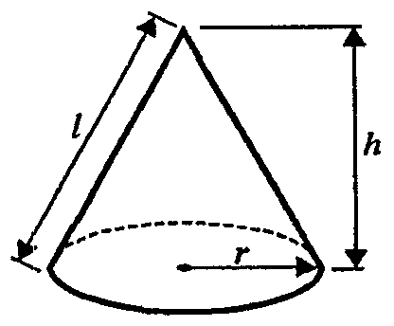
Surface area of sphere = 4 r²

Volume of cone = $\frac{4}{3}$ r²h
Curved surface area of cone =  rl
A
a
b
c
C
B

In any triangle ABC

Sine Rule: $\frac{a}{\text{sin}A}$ = $\frac{b}{\text{sin}B}$ = $\frac{c}{\text{sin}C}$
Cosine Rule: a² = b² + c² –2bc cos A
Area of a triangle = $\frac{1}{2}$ ab sin C
The Quadratic Equation
The solutions of ax² + bx + c = 0, where a  0, are given by x = $\frac{−b±\sqrt{(b^{2}−4\text{ac})}}{2a}$
Higher – Section A – Calculator

1. Use your calculator to work out the value of

$$\frac{\text{32}\text{.}6 × \text{12}\text{.}4}{\text{21}\text{.}4 − \text{13}\text{.}9}$$

(a) Write down all the figures on your calculator display.

…………………..…
(2)
(b) Write your answer correct to 3 significant figures.

…………………..…
(1)
(Total 3 marks)

2. Change 10 kilograms to pounds.

......................... pounds
(Total 2 marks)

3. Here is a trapezium.
6 cm
Diagram NOT accurately drawn

5 cm

8 cm

Work out the area of the trapezium.

………………… cm²
(Total 2 marks)
4. Factorise 7a + 21

..........................
(Total 1 mark)

5. OABCDEFG is a cuboid.

(a) Write down the coordinates of D.

(…….., …….., ……..)
(1)

(b) Write down the coordinates of G.

(…….., …….., ……..)
(1)

- Work out the area of the face CBFG

………………
(2)
(Total 4 marks)

6.

The diagram shows the position of each of three buildings in a town.
The bearing of the Hospital from the Art gallery is 072°
The cinema is due East of the hospital.
The distance from the Hospital to the Art gallery is equal to the distance from the Hospital to the Cinema.

Work out the bearing of the Cinema from the Art gallery.

………………°
(Total 3 marks)

7.
3.
A
B
O
C
48°
Diagram NOT accurately drawn

B and C are points on the circle, centre O.
AB and AC are tangents to the circle.
Angle BAC = 48°

(a) Find the size of angle ABO.
Give a reason for your answer.

…………………………………………………………………………………………………..

…………………………………………………………………………………………………...

………………..°
(2)

(b) Find the size of angle BOC.

………………..°
(2)
(Total 4 marks)

8. (a) Factorise 2x² − 35x + 98

……………..…….……
(2)

- Write as a single fraction in its simplest form

…………………
(4)

(Total 6 marks)

Total 25 marks
Higher – Section B – Non – Calculator

A
B
C
D
110°
x°
y°
1.

AB is parallel to CD.

(a) Work out the size of angle x°.

.......................... °
(1)
(b) (i) Work out the size of angle y°.

.......................... °
(ii) Give a reason for your answer.

……………………………………………………………………………………

……………………………………………………………………………………
(2)
(Total 3 marks)

2. Simplify

………………………..
(Total 2 marks)

3. Work out

(i) 8⁰

.................................
(1)

(ii) 5⁻²

.................................
(1)
(iii)

.................................
(1)
(Total 3 marks)

4. (i) Express 72 and 96 as a product of their prime factors.

72 = …………...................

96 = …………...................
(3)

(ii) Use your answer to (i) to work out the Highest Common Factor of 72 and 96.

…….........................
(2)
(Total 5 marks)

5. (a) Expand the brackets p(q − p²)

…………...................
(1)

(b) Expand and simplify 5(3p + 2) − 2(5p − 3)

…………...................
(2)
(Total 3 marks)

6. (a) (i) Write 40 000 000 in standard form.

…………...................
(i) Write 3  10⁻⁵ as an ordinary number.

…………...................
(2)
(b) Work out the value of

3  10⁻⁵  40 000 000

Give your answer in standard form.

…………...................
(2)
(Total 4 marks)

7. (i) Convert the recurring decimal 0.$\overset{˙}{3}\overset{˙}{6}$ to a fraction.

…………………..…
(2)
(ii) Convert the recurring decimal 2.1$\overset{˙}{3}\overset{˙}{6}$ to a mixed number.
Give your answer in its simplest form.

…………………..…
(3)
(Total 5 marks)

Total: 25 marks

BLANK PAGE
1. (a) $\frac{\text{32}\text{.}6 × \text{12}\text{.}4}{\text{21}\text{.}4 −\text{13}\text{.}9} = \frac{\text{404}\text{.}\text{24}}{6\text{.}5}$ = 62.19076923
(b) 62.2

2. 22 pounds
3. 35 cm²
4. 7(a + 3)
5. (a) (0, 2, 0)
(b) (0, 2, 3)
(c) 8
6. 081º
7. (a) Angle ABO = 90°
The angle between the tangent and the radius is 90°
(b) Angle BOC = 132°

8. (a) 2x² − 35x + 98 = (2x − 7)(x − 14)
(b)

Section B
1. (a) 180° − 110° = 70°
(b) (i) 110°
(ii) y = 110° as they are corresponding angles
2. 5⁴
3. (i) 8⁰ = 1
(ii) 5⁻² = $\frac{1}{5^{2}} = \frac{1}{\text{25}}$
(iii) 3
4. (i) 72 = 2  2  2  3  3
96 = 2  2  2  2  2  3
(ii) HCF = 2  2  2  3 = 24
5. (a) p(q − p²) = pq − p³
(b) 5(3p + 2) − 2(5p − 3)
= 15p + 10 − 10p + 6
= 5p + 16
6. (a) (i) 40000000 = 4  10⁷
(ii) 3  10⁻⁵ = 0.00003
(b) 3  10⁻⁵  40000000
= 3  10⁻⁵  4  10⁷
= 12  10²
= 1.2  10¹  10²
= 1.2  10³
7. (i) x = $\frac{\text{36}}{\text{99}}$ or $\frac{4}{\text{11}}$
(ii) x = $\frac{\text{211}\text{.}5}{\text{99}}$ or $\frac{\text{2115}}{\text{990}}$ = 2$\frac{\text{135}}{\text{990}}= 2\frac{3}{\text{22}}$

