

GCSE in Mathematics B
Modular 2544
Unit 3
Number, Algebra, Shape Space and Measures 1
Practice Paper D
Higher
(Calculator and Non – Calculator)
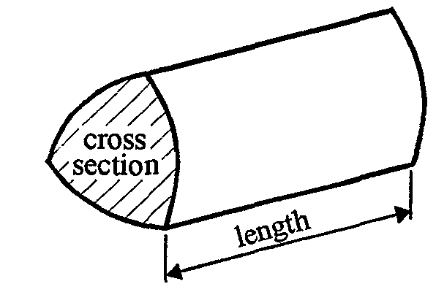
EDEXCEL
GCSE Mathematics 2540/2544
Formulae sheet — Higher tier

Volume of prism = area of cross-section  length

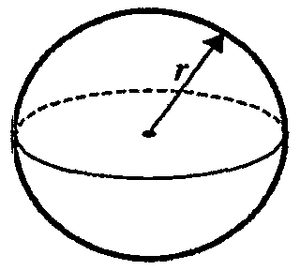
Volume of sphere = $\frac{4}{3}$ r³

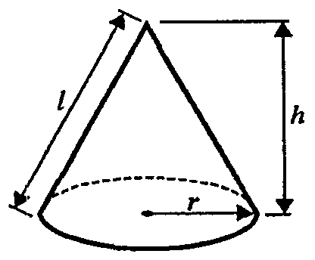
Surface area of sphere = 4 r²

Volume of cone = $\frac{4}{3}$ r²h
Curved surface area of cone =  rl
A
a
b
c
C
B

In any triangle ABC

Sine Rule: $\frac{a}{\text{sin}A}$ = $\frac{b}{\text{sin}B}$ = $\frac{c}{\text{sin}C}$
Cosine Rule: a² = b² + c² –2bc cos A
Area of a triangle = $\frac{1}{2}$ ab sin C
The Quadratic Equation
The solutions of ax² + bx + c = 0, where a  0, are given by x = $\frac{−b±\sqrt{(b^{2}−4\text{ac})}}{2a}$
Higher – Section A – Calculator

1.
A
94°
E
D
C
y
35°
B
Diagram NOT accurately drawn

Find the size of the angle marked y.
Give your reason for your answer.

y = …….…….°

…………………………………………………………………………………………………..

…………………………………………………………………………………………………..
(Total 2 marks)

2. Here are the first four terms of an arithmetic sequences.

3 7 11 15

Write down, in terms of n, and expression for the nth term of the sequence.

……..…………..
(Total 2 marks)

3. (a) Express 120 as the product of powers of its prime factors.

..........................
(3)
(b) Find the Lowest Common Multiple of 120 and 150

.........................
(2)
(Total 5 marks)

4. (a) Expand

4(2a + 3)

.................................
(1)

(b) Factorise fully

20xy + 30x²

.................................
(2)
(Total 3 marks)

5. Jerry measures the length of a piece of wood.
The piece of wood is 67cm correct to the nearest centimetre.

(a) Write down the maximum possible length it could be.

…………...................
(1)

(b) Write down the minimum possible length it could be.

…….........................
(1)
(Total 2 marks)

6. Factorise x² + 2x − 15

…………...................
(Total 2 marks)

7.

Calculate the surface area of the triangular prism.

….…………. cm²
(Total 3 marks)

8.
Diagram NOT accurately drawn
B and C are points on a circle, centre O.
AB and AC are tangents to the circle.
Angle BOC = 108°.
Work out the size of angle BAO.
Give a reason for each stage in your working.

.............................°
(Total 3 marks)

9. Simplify fully

………………..
(Total 3 marks)

Total: 25 marks
Higher –Section B – Non-Calculator

1.
5 + 3  (6 − 4)

Azia and Jean answered the same question.

Azia said that 5 + 3  (6 − 4) is 11
Jean said that 5 + 3  (6 − 4) is 16

Explain who is correct.

……………………………………………………………………..……………………

…………………………………………………………………….…………….………

………………………………………………………………………………..…………

(Total 2 marks)

2. 32  129 = 4128

Write down the value of

(i) 3.2  1.29

………………..
(1)
(ii) 0.32  129 000

………………..
(1)
(Total 2 marks)

3. Work out 20% of 1 800

……………..…….……
(Total 2 marks)

4. (a) Write 3.8  10³ as an ordinary number.

…………………..…
(1)
(b) Write the number 0.00045 in standard form.

…………………..…
(1)
(Total 2 marks)

5. Expand and simplify (t + 4)(t − 2)

………………
(Total 2 marks)

6. (a) Simplify 6⁵  6⁸

………………
(1)
(b) Simplify

……………..
(2)
(Total 3 marks)
7.
x
y
z
O
A
B
C
D
E
F
G
Diagram NOT accurately drawn

(12, 4, 6)

The diagram shows a cuboid.
The coordinates of the vertex F are (12, 4, 6).

- Write down the coordinates of the vertex E.

(…… , …… , ……)
(1)
(b) Find the coordinates of the midpoint of CF.

(…… , …… , ……)
(2)
(Total 3 marks)

8. Work out 24.3  5.7
You must show all your working.

………………..
(Total 3 marks)

9. Change the decimal $0\text{.}\overset{˙}{4}\overset{˙}{5}$ into a fraction in its lowest terms.

…………...................
(Total 3 marks)

10. Write as a single fraction in its simplest form.

$\frac{3}{x + 1} + \frac{5x}{2x^{2} + 7x + 5}$

…….…………………..…..
(Total 3 marks)

Total 25 marks

1. 35º ; alternate angles

2. (−1), 3, 7, 11, 15 4n − 1

3. (a) 120 = 2  2  2  3  5
(b) 150, 300, 450, 600 LCM = 600
   
4. (a) 8x + 12
(b) 10x(2y + 3x)
5. (a) 67.5 cm
(b) 66.5 cm
6. (x + 5)(x – 3)
7. 96 cm²
8. 72º; Angles between tangent and radius is 90º; Angles in a quadrilateral add to 360º
9.

Section B
1. Azia is correct BIDMAS Do bracket (6 − 4) = 2 then multiplication
3  (6 − 4) = 3  2 = 6 then add 5 6 + 5 = 11
2. (i) 4.128 (ii)-.32  129000 = 32  1290 = 41280
3. 360
4. (a) 3.8  10³ = 3800
(b) 0.00045 = 4.5  10⁻⁴
5. t² + 2t – 8
6. (a) 6¹³
(b) 6⁸
7. (a) (12, 4, 0)
(b) (6, 2, 6)
8. 138.51
9. x = $\frac{\text{45}}{\text{99}} = \frac{5}{\text{11}}$
10. $\frac{3}{x + 1} + \frac{5x}{2x^{2} + 7x + 5}$
= $\frac{3}{x + 1} + \frac{5x}{(x + 1)(2x + 5)}$
= $\frac{3(2x + 5) + 5x}{(x + 1)(2x + 5)}$
= $\frac{6x + \text{15} + 5x}{(x + 1)(2x + 5)}$
= $\frac{\text{11}x + \text{15}}{(x + 1)(2x + 5)}$

