

GCSE in Mathematics B
Modular 2544
Unit 3 Number, Algebra, Shape Space and Measures 1
Practice Paper B
Higher
(Calculator and Non – Calculator)
EDEXCEL
GCSE Mathematics 2540/2544
Formulae sheet — Higher tier
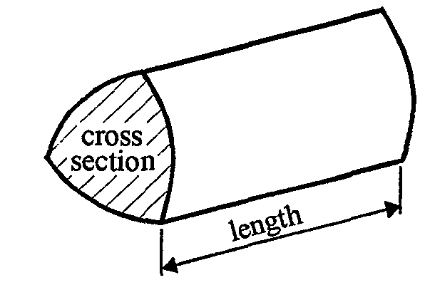
Volume of prism = area of cross-section  length

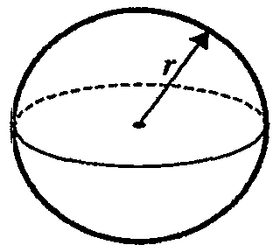
Volume of sphere = $\frac{4}{3}$ r³

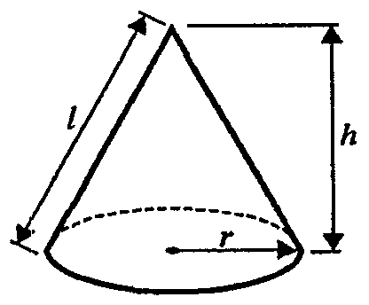
Surface area of sphere = 4 r²

Volume of cone = $\frac{1}{3}$ r²h
Curved surface area of cone =  rl
A
a
b
c
C
B

In any triangle ABC

Sine Rule: $\frac{a}{\text{sin}A}$ = $\frac{b}{\text{sin}B}$ = $\frac{c}{\text{sin}C}$
Cosine Rule: a² = b² + c² –2bc cos A
Area of a triangle = $\frac{1}{2}$ ab sin C
The Quadratic Equation
The solutions of ax² + bx + c = 0, where a  0, are given by x = $\frac{−b±\sqrt{(b^{2}−4\text{ac})}}{2a}$
Higher – Section A – Calculator

1. (a) Expand 6(x + 3)

………………
(1)

(b) Factorise 15y – 35

…………….
(1)
(Total 2 marks)

2. Calculate the value of

$\frac{\sqrt{9\text{.}\text{83} − 1\text{.}{\text{67}}^{2}}}{\text{23}\text{.}8 − 4\text{.}\text{47} × 5\text{.}\text{12}}$

...................................
(Total 3 marks)

3. Here are the first five terms of an arithmetic sequences.

−1 3 7 11 15

(a) Find, in terms of n, an expression for the nth term of this sequence.

……..……………………..
(2)

In another arithmetic sequence the nth term is 8n − 16

John says that there is a number that is in both sequences.

(b) Explain why John is wrong.

………………………………………………………………..…………………………………
…………………………………………………………………………………………………..
…………………………………………………………………………………………………..
(2)
(Total 4 marks)

4. Expand and simplify

(i) 4(x + 5) + 3(x − 7)

........................
(2)
(ii) (x + 3)(x + 2)

........................
(2)
(Total 4 marks)

5. Daniel leaves his house at 07 00.

He drives 87 miles to work.
He drives at an average speed of 36 miles per hour.

At what time does Daniel arrive at work?

...........................
(Total 3 marks)

6. The diagram shows a trapezium ABCD.
C
D
5.2 m
A
B
1.6 m
4.8 m
Diagram NOT accurately drawn

AB is parallel to DC.

AB = 4.8m, DC = 5.2m, AD = 1.6m,
Angle BAD = 90°,
Angle ADC = 90°
Calculate the area of trapezium ABCD.
State the units of your answer.

…………………... ..................
(Total 3 marks)

7.
Diagram NOT accurately drawn
A and B are points on the circumference of a circle, centre 0.
TA and TB are tangents to the circle.

Calculate the size of the angle ATO when angle AOT = 56°
Give a reason for each stage in your working.

………………….°
(Total 3 marks)

- Write as a single fraction in its simplest form.

……………………………
(Total 3 marks)

Total: 25 marks
Higher –Section B – Non-Calculator

1. Sarah measures the length of a foot path.
The length of the foot path is 27m correct to the nearest metre.

- Write down the maximum possible length of the foot path.

….……………m

- Write down the minimum possible length of the foot path.

………………..m
(Total 2 marks)

2.

x°
110°
79°
Diagram NOT accurately drawn.

(a) Find the size of the angle marked x°

………………..°
(2)
(b) Give a reason for your answer.

………………………………………………………………………………………………….
(1)
(Total 3 marks)

3. (a) Find the highest common factor of 18 and 24

………………..
(1)
(b) Find the lowest common multiple of 18 and 24

………………..
(2)
(Total 3 marks)

4. Write the fractions $\frac{5}{8}, \frac{3}{4}, \frac{\text{17}}{\text{24}}, \frac{7}{\text{12}}$ in ascending order.

………………….……
(Total 2 marks)

5. Work out 45% of £24

£…………………
(Total 2 marks)

6. Evaluate
(i) 7⁰

………………
(ii) 3⁻²

………………
(Total 2 marks)

7. Work out the value of

8.4  0.04

….………….…….
(Total 2 marks)

8. The diagram shows a prism.
The cross section of the prism is a triangle of area 9.3 cm2.
The length of the prism is 10 cm.
Work out the volume of the prism.
State the units of your answer.

……………………cm³
(Total 2 marks)

9. (a) Write the number 5.01  10⁴ as an ordinary number.

….………..…….
(1)

(b) Write the number 0.0009 in standard form.

….………..…….
(1)
(Total 2 marks)

10. (a) Factorise
9x² − 6x + 1

….………..…….
(2)
(b) Simplify
$\frac{6x^{2} + 7x − 3}{9x^{2} − 6x + 1}$

….………..…….
(3)
(Total 5 marks)
Total 25 marks

1. (a) 6x + 18
(b) 5(3y – 7)

2. $\frac{\sqrt{7\text{.}\text{0411}}}{\text{23}\text{.}8 − \text{22}\text{.}\text{8864}}$= $\frac{2\text{.}\text{653507113}}{0\text{.}\text{9136}}$ = 2.904451744 = 20904…

3. (a) (−5), −1, 3, 7, 11, 15 4n − 5
(b) the first sequence only has odd numbers and the 2nd sequence only has even number

4. (a) 4(x + 5) + 3(x − 7) = 4x + 20 + 3x − 21) = 7x − 1
(b) x² + 5x + 6
5. D = 87 S = 36 T = D  S = 87  36 = 20416 hour
= 2 hours (0.41$\overset{˙}{6}$  60 = 25 mins  arrives 09.25
6. Area trapezium = $\frac{1}{2}$ (sum of parallel sides)  height
= $\frac{1}{2}$ (4.8 + 5.2)  1.6 = 5  1.6 = 8m² (don’t forget the units m²)
Angle AOP = 62° (2 tangents to a circle make congruent triangles)
7. Angle between tangent and radius = 90°
Angle T = 180 − 90 − 56 = 34° (angle in a triangle add up to 180°)
Angle ATO = 34°
8.

Section B
1. (i) 27.5 m (ii) 26.5 m
2. (a) x = 79°
(b) alternate angles
3. (a) 18 = 2  3  3 24 = 2  2  2  3
HCF = 2  3 = 6
(b) LCM = 2  2  2  3  3 = 72
4. $\frac{5}{8}, \frac{3}{4}, \frac{\text{17}}{\text{24}}, \frac{7}{\text{12}}$ $\frac{\text{15}}{\text{24}}, \frac{\text{18}}{\text{24}}, \frac{\text{17}}{\text{24}}, \frac{\text{14}}{\text{24}}$
$\frac{7}{\text{12}}, \frac{5}{8}, \frac{\text{17}}{\text{24}}, \frac{3}{4}$
5. $\frac{\text{45}}{\text{100}}$  24 = $\frac{\text{54}}{5}$ = £10.80
or 10% = £2.40 20% = £4.80 40% = £9.60
5% = £1.20 45% = £10.80
6. (i) 1
- 3⁻² = $\frac{1}{3^{2}} = \frac{1}{9}$
7. $\frac{8\text{.}4}{0\text{.}\text{04}}$ = $\frac{\text{840}}{4}$ = 210
8. 93 cm²
9. (i) 5.01  10⁴ = 50100
(ii) 0.0009 = 9  10⁻⁴
9. (a) 9x² − 6x + 1 = (3x − 1)(3x − 1)
(b) $\frac{6x^{2} + 7x − 3}{9x^{2} − 6x + 1}$ = $\frac{(3x − 1)(2x + 3)}{(3x − 1)(3x − 1)}$ = $\frac{2x + 3}{3x − 1}$

