

GCSE in Mathematics B
Modular 2544
Unit 3 Number, Algebra, Shape Space and Measures 1
Practice Paper A
Higher
(Calculator and Non – Calculator)
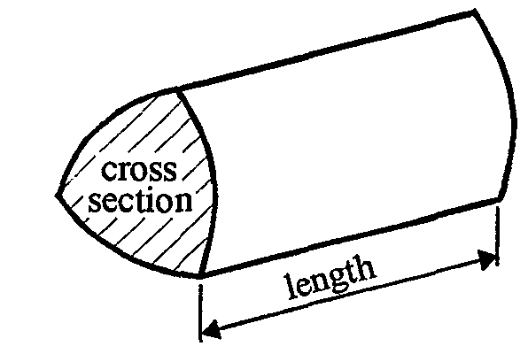
EDEXCEL
GCSE Mathematics 2540/2544
Formulae sheet — Higher tier

Volume of prism = area of cross-section  length

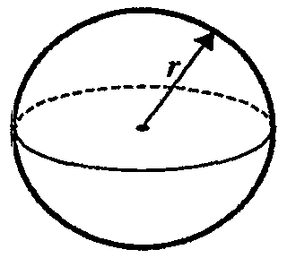
Volume of sphere = $\frac{4}{3}$ r³

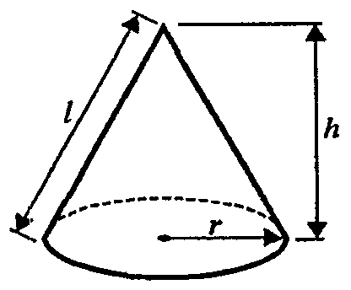
Surface area of sphere = 4 r²

Volume of cone = $\frac{4}{3}$ r²h
Curved surface area of cone =  rl
A
a
b
c
C
B

In any triangle ABC

Sine Rule: $\frac{a}{\text{sin}A}$ = $\frac{b}{\text{sin}B}$ = $\frac{c}{\text{sin}C}$
Cosine Rule: a² = b² + c² –2bc cos A
Area of a triangle = $\frac{1}{2}$ ab sin C
The Quadratic Equation
The solutions of ax² + bx + c = 0, where a  0, are given by x = $\frac{−b±\sqrt{(b^{2}−4\text{ac})}}{2a}$
Higher – Section A – Calculator

1.
y
Diagram NOT accurately drawn
B

A

x
O

A has coordinates (2, 3)
B has coordinates (10, 7)

Find the coordinates of the mid-point of the lines AB.

(………. , ……….)
(Total 2 marks)

2. (a) Use your calculator to work out the value of

$\frac{6\text{.}\text{27} × 4\text{.}\text{52}}{4\text{.}\text{81} + 9\text{.}\text{63}}$

........................
(2)
(b) Write your answer to part (a) correct to 3 significant figures.

........................
(1)
(Total 3 marks)

3. Work out (8  10⁹)  (4  10²)

Give your answer in standard form.

……………………

(Total 2 marks)

4. The first four terms of an arithmetic sequence are

71, 74, 77, 80

Find, in terms of n, an expression for the nth term of this sequence.

……………………..
(Total 2 marks)

5. (a) Expand 5(x + 3)

...................................
(1)
(b) Factorise 3y – 12

……………………
(1)
(c) Factorise

x² + 7x + 6

...................................
(2)

(Total 4 marks)

6. Mr Smith owns minibuses and coaches.

Each minibus has 12 seats.

(a) Write an expression, in terms of m, for the number of seats in m minibuses.

….………….…….
(1)
Each coach has 48 seats.

(b) Write an expression, in terms of m and c, for the number of seats on m minibuses and c coaches

….………….…….
(2)
(Total 3 marks)

7. Here is a triangular prism.

Diagram NOT accurately drawn

5 cm

12 cm

8 cm

Calculate the volume of the prism.

……………. cm³
(Total 3 marks)
8.
56°
B
O
A
P
Diagram NOT accurately drawn

A and B are points on the circumference of the circle, centre O.
PA and PB are tangents to the circle.
Angle APB = 56°

Calculate the size of angle AOP.
Give a reason for each stage in your working.

.....................
(Total 3 marks)

9. Simplify $\frac{4x^{2} − 9}{2x^{2} − 5x + 3}$

……..…………
(Total 3 marks)

Total: 25 marks
Higher – Section B – Non – Calculator

1. (a) Complete the table of values for y = 2x + 3
x | –2 | –1 | 0 | 1 | 2 | 3
y |  | 1 | 3

(2)
(b) On the grid, draw the graph of y = 2x + 3
(2)
(Total 4 marks)

2. Work out
$\frac{\text{40}\text{.}8}{1\text{.}2}$

…………
(2)
(Total 2 marks)

3. Here are two fractions

$\frac{3}{4}$ and $\frac{5}{7}$

Explain which is the smaller fraction.
You may use the grids to help with your explanation.

……………………………………………………………………………………………
……………………………………………………………………………………………
……………………………………………………………………………………………

(Total 3 marks)

4. Here is a right-angled triangle.

5x + 10
3x + 6
4x + 8

The lengths of the three sides of the triangle are 3x + 6, 4x + 8 and 5x + 10
All measurements are in centimetres.

Find an expression, in terms of x, for the perimeter of the triangle.
Give your answer in its simplest form.

………………

(Total 2 marks)
5.

AC and BD are straight lines which cross at E.
AD is parallel to BC.

(a) (i) Find the size of the angle marked x°

…………………°
(ii) Give a reason for your answer.

……………………………………………………………………………………………
……………………………………………………………………………………………
(2)
(b) (i) Find the size of the angle marked y°

…………………°
(ii) Give a reason for your answer.

……………………………………………………………………………………………
……………………………………………………………………………………………
(2)
(Total 4 marks)

6. (a) Evaluate 4⁰
………………
(1)
(b) Evaluate 5⁻²

………………
(1)

(Total 2 marks)

7. (a) Factorise x² − 2x − 15

….………..……….…….
(2)

(b) Expand and simplify

(2x + 1)(3x − 2)

….…….…….
(2)
(c) Factorise completely
6a³ − 9a²

………………
(2)
(Total 6 marks)

8. Convert the recurring decimal $0\text{.}\overset{˙}{2}\overset{˙}{9}$ to a fraction.

……………………
(Total 2 marks)

Total 25 marks

BLANK PAGE
1. (6, 5)
2. (a) $\frac{\text{28}\text{.}\text{3404}}{\text{14}\text{.}\text{44}}$ = 1.962631579

(b) 1.96
3. 2  10⁷
4. 3n + 68

5. (a) 5x + 15
(b) 3(y – 4)
(b) x² + 7x + 6 = (x + 6)(x + 1)

6. (a) 12m
(b) 12m + 48c
7. 240 cm³
8. Angle OBP – angle OAP = 90°
(angle between tangent and radius = 90°)
Angle AOB = 360 − 90 − 90 − 56 = 124°
(angle in a quadrilateral add up to 360°)
Angle AOP = 62° (2 tangents to a circle make congruent triangles)

9.$\frac{4x^{2} − 9}{2x^{2} − 5x + 3}$ = $\frac{(2x + 3) (2x − 3)}{(2x − 3) (x − 1)} = \frac{2x + 3}{x − 1}$

Section B
1. (a) -1, 5, 7, 9
(b) Correct graph
2. $\frac{\text{40}\text{.}8}{1\text{.}2} = \frac{\text{408}}{\text{12}}$ = 408  12 = 34
3.
$$\frac{3}{4}$$ |  |  |  |  |  |  |  |  |  |  |  |  |  |  |  | $$\frac{5}{7}$$
Shade 21 Shade 20
$\frac{5}{7}$ is smaller
4. 3x + 6 + 4x + 8 + 5x + 10 = 12x + 24
5. (a) (i) 72º (ii) Alternate angles
(b) (i) 50°
(ii) Angles on a straight line sum to 180º; Angles in a triangle sum to 180º
6. (i) 1
(ii) or 0.04
7. (a) (x – 5)(x + 3)
(b) 6x² – x – 2
(c) 3a²(2a – 3)
8.
x | = | 0.292929
100x | = | 29.2929…
x | = | 0.2929…
99x | = | 29
x | = | 29/99

