

GCSE in Mathematics B
Modular 2544
Unit 2 Handling Data
Practice Paper C
Higher
(Calculator and Non–Calculator)
Higher Unit 2 Paper C Section A Calculator section

1. Four teams, City, Rovers, Town and United play a competition to win a cup. Only one team can win the cup.

The table below shows the probabilities of City or Rovers or Town winning the cup.

City | Rovers | Town | United
0.38 | 0.27 | 0.14 | x

Work out the value of x.

.........................
(Total 2 marks)

2. The table shows the frequency distribution of students absences for a year.

Absences d (days) | Frequency
0 < d < 5 | 4
5 ≤ d < 10 | 6
10 ≤ d < 15 | 8
15 ≤ d < 20 | 5
20 ≤ d < 25 | 4
25 ≤ d < 30 | 3

Draw a frequency polygon for this frequency distribution.

(Total 2 marks)

3. The owner of a music shop recorded the number of CDs sold every 3 months.

The table shows his records from January 2004 to June 2005.

Year | Months | Number of CDs
2004 | Jan – Mar | 270
 | Apr – Jun | 324
 | Jul – Sept | 300
 | Oct – Dec | 258
2005 | Jan – Mar | 310
 | Apr – Jun | 336

(a) Calculate the complete set of four-point moving averages for this information.
The first one has been done for you.

288, ………… , ………..
(3)

(b) What trend do these moving averages suggest?

…………………………………………………………………………………………
(1)
(Total 3 marks)

4. Amy has 10 CDs in a CD holder.
She has 7 Edex CDs in the CD holder.
Amy takes one of these CDs at random and puts the CD on the table.
She then takes another one of these CDs at random.
(a) Complete the probability tree diagram.

..........
Second choice
..........
First choice
..........
..........
..........
EDEX
CD
EDEX
CD
EDEX
CD
NOT-EDEX
CD
NOT-EDEX
CD
NOT-EDEX
CD
(3)
(b) Find the probability that Amy will pick two Edex CDs.

.....................
(2)

TOTAL FOR SECTION B: 15 MARKS

Higher Unit 2 Paper C Section B Non-Calculator section

1. Tony throws a biased dice 100 times.
The table shows his results.
Score | Frequency
1 | 12
2 | 13
3 | 17
4 | 10
5 | 18
6 | 30
He throws the dice once more.
(a) Find an estimate for the probability that he will get a 6.

.....................................
(1)
Emma has a biased coin.
The probability that the biased coin will land on a head is 0.2
Emma is going to throw the coin 300 times.
(b) Work out an estimate for the number of times the coin will land on a head.

.....................................
(2)
(Total 3 marks)

2. The scatter graph shows some information about six new-born baby apes.
For each baby ape, it shows the mother’s leg length and the baby ape’s birth weight.

The table shows the mother’s leg length and the birth weight of two more baby apes.
Mother’s leg length (cm) | 50 | 65
Baby ape’s birth weight (kg) | 1.6 | 1.75

(a) On the scatter graph above, plot the information from the table.
(1)

(b) Describe the correlation between a mother’s leg length and her baby ape’s birth weight.
………………………………………………………
(1)
(c) Draw a line of best fit on the diagram.
(1)

A mother’s leg length is 55 cm.

(d) Use your line of best fit to estimate the birth weight of her baby ape.
……………………kg
(1)
(Total 4 marks)
3. A student wanted to find out how many pizzas adults ate.
He used this question on a questionnaire.
"How many pizzas have you eaten?"

A few A lot
(a) Write down two things that are wrong with this question.
1.

2.

(2)

(b) Design a better question that the student can use to find out how many pizzas adults ate.
You should include some response boxes.

(2)
(Total 4 marks)

4. Here are four cumulative frequency diagrams.

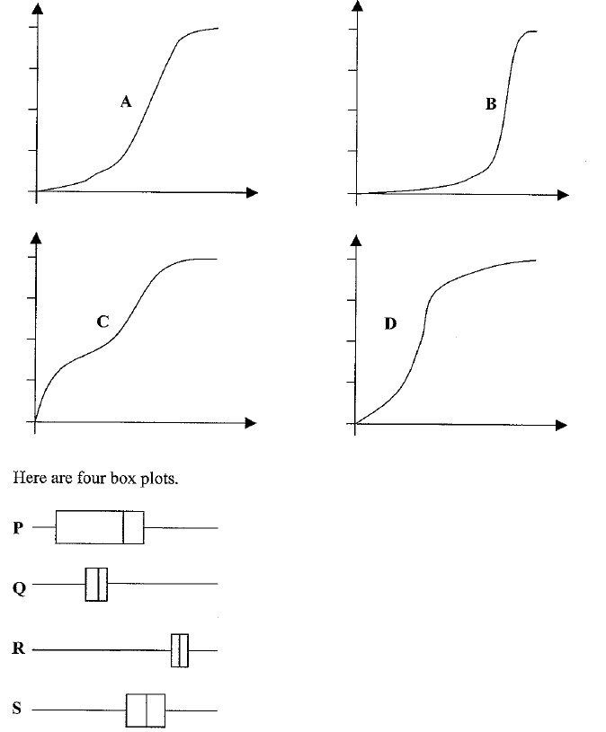

For each box plot, write down the letter of the appropriate cumulative frequency diagram.

P and ………
Q and ………
R and ………

S and ………

(Total 2 marks)
5. This histogram gives information about the books sold in a bookshop one Saturday.
Use the histogram to complete the table.

Price (P) in pounds (£) | Frequency
0 < P ≤ 5
5 < P ≤ 10
10 < P ≤ 20
20 < P ≤ 40
(Total 2 marks)

TOTAL FOR SECTION B: 15 MARKS

Mark Scheme Paper C
Modular 2544 Unit 2 = Data Handling

Higher – Section A – Calculator

1. 1 − 0.79 = 0.21

2.
3. (a) 298, 301 (b) sales are increasing

4. (a) $\frac{6}{9}$ E
$\frac{7}{\text{10}}$ E
$\frac{3}{9}$ not

$\frac{7}{9}$ E
$\frac{3}{\text{10}}$ not
$\frac{2}{9}$ not
(b) $\frac{7}{\text{10}}$ × $\frac{6}{9}$ = $\frac{\text{42}}{\text{90}}$ (or $\frac{7}{\text{15}}$ )
Mark Scheme Paper C
Modular 2544 Unit 2 = Data Handling

Higher – Section B – Non-Calculator

1. (a) $\frac{\text{30}}{\text{100}}$ (or $\frac{3}{\text{10}}$)

2. 60

3. (a) (b) Positive (c) Line (d) 1.648 (read from their graph)

3. (a) There is no time frame
The choices are too vague
There is no option if you don’t eat any

(b) How many pizzas do you eat each month?

0 1−3 4−6 more than 6

4. P and S Q and D R and B S and P

5.
Price (P) in pounds (£) | Frequency
0 < P ≤ 5 | 40
5 < P ≤ 10 | 60
10 < P ≤ 20 | 130
20 < P ≤ 40 | 80

