

GCSE in Mathematics B
Modular 2544
Unit 3
Number, Algebra, Shape Space and Measures 1
Practice Paper F
Foundation
(Calculator and Non – Calculator)
Formulae Sheets
EDEXCEL

GCSE Mathematics

Formulae Sheet Foundation Tier

Area of trapezium = $\frac{1}{2}$(a + b)h
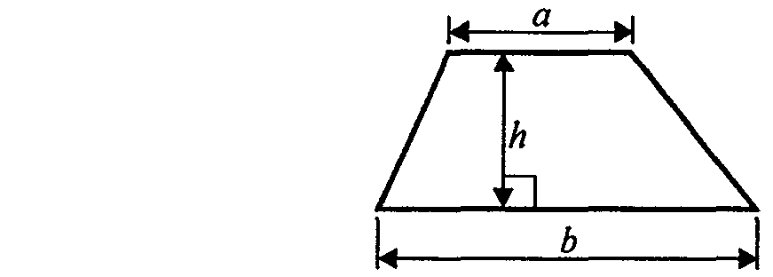

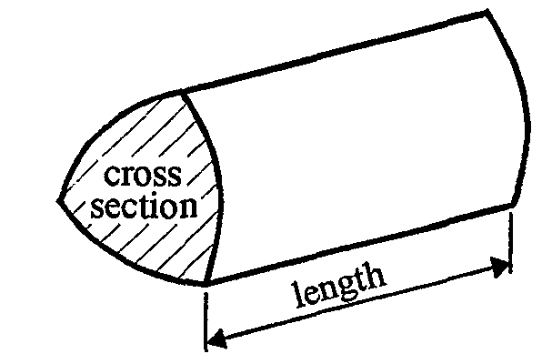

Volume of prism = area of cross section x length
Foundation – Section A – Calculator

1. (i) (ii)

(iii)

Write down the reading on each of these scales.
- ....................................... km/h

- .......................................... ml

(iii) .......................................... °C
(Total 3 marks)

2. Rizwan buys
6 stamps at 25p each
2 packs of postcards at 89p per pack
1 pack of labels at £1.09

He pays with a £10 note.
Work out how much change Rizwan should get.

£ ......................................
(Total 3 marks)

3.

(a) Write down the coordinates of point A.
( ........................ , ........................ )
(1)
(b) On the grid, plot the point (5, 3).
Label this point with the letter B.
(1)
(c) On the grid, plot the point (4, –2).
Label this point with the letter C.
(1)
(Total 3 marks)

4. (a) Simplify 5m + 3m – 2m

............................................
(1)
(b) Simplify p + 7q + 3p – 2q

............................................
(2)
(c) Multiply out 3(t – 4)

............................................
(1)
(d) Simplify 4a × 3b

............................................
(1)
(Total 5 marks)

5. Work out 70% of £340

£ ..........................................
(Total 2 marks)

6.

Maria correctly converted each of these fractions to decimals.
Put a ring around each fraction which gave a recurring decimal.

(Total 2 marks)

7. Use your calculator to work out

$\frac{\text{15}\text{.}1 + 4\text{.}\text{82}}{6\text{.}2 − 3\text{.}7}$

Write down all the figures on your calculator display.

........................................
(Total 2 marks)

8. Expand and simplify (x + 1)(x – 7)

........................................
(Total 2 marks)

9. The diagram shows a 6-sided shape made from a rectangle and a right-angled triangle.

Work out the total area of the 6-sided shape.

...........................cm²
(Total 3 marks)

Total : 25 marks
Foundation – Section B – Non-calculator

1. (a) Write down the number fifty thousand, three hundred and seventy eight in
figures.
............................................
(1)
(b) Write down the value of the 4 in the number 7643
............................................
(1)
(c) Write 7643 to the nearest 100
............................................
(1)
(Total 3 marks)

2. Here is a rectangle.
Diagram NOT
accurately drawn
3 cm
4 cm

(a) Work out the area of the rectangle.

................................. cm²
(2)

(b) Work out the perimeter of the rectangle.

................................ cm
(1)
(Total 3 marks)

- Write the number 7623 correct to 1 significant figure.

........................................
(Total 1 mark)

4. Here are the first four terms of a number sequence.

2 7 12 17

(a) Write down the next two terms of this number sequence.

………….. , ………..
(2)
(b) Write down the 8th term of this number sequence.

............................................
(1)

(Total 3 marks)

5. Work out the cube of 6

............................................
(Total 1 mark)

6.

The diagram shows a cuboid.
Work out the volume of the cuboid.

.................................. cm³
(Total 2 marks)

7. On the grid, draw the graph of y = 3x + 1

(Total 3 marks)

8. Factorise completely 6q + 12

............................................
(Total 2 marks)

9.
BEG and CFG are straight lines.
ABC is parallel to DEF.
Angle ABE = 48°.
Angle BCF = 30°.

(a) (i) Write down the size of the angle marked x.

x = ...................
(ii) Give a reason for your answer.
...........................................................................................................................
(2)
(b) (i) Write down the size of the angle marked y.

y = ...................
(ii) Give a reason for your answer.

...........................................................................................................................
(2)
(Total 4 marks)

10. Work out an estimate for the value of

...........................................
(Total 3 marks)

Total : 25 marks

BLANK PAGE

Practice Paper F

Foundation Unit 3 – Answers
Section A
1. (i) 65 ± 1 (ii) 160 ± 2 (iii) 32 ± 0.5
2. 25 × 6 = 150
89 × 2 = 178
109 × 1 = 109
1000 – (“150” + “178” +109) = £5.63
3. (a) (1, 2) (b) (5, 3) plotted (c) (4, –2) plotted
4. (a) 6m (b) 4p + 5q (c) 3t – 12 (d) 12ab

5. × 340 = 7 × 34 = 238
6. $\frac{1}{3}, \frac{7}{\text{12}}$
7. = 7.968
8. x2 – 7x + x – 7 = x2 – 6x – 7
- 6 × 5  2 = 15
15 + 6  4 = 39
Section B
1. (a) 50378 (b) 40 (c) 7600
2. (a) 4 × 3 = 12 cm² (b) 14 cm
3. 8000
4. (a) 22, 27 (b) 37
5. 216
6. 20 × 5 × 30 = 3000 cm³
7. x: –1 0 1 2 3
y: –2 1 4 7 10 Line drawn
8. 6(q + 2)
9. (a) (i) 48 (ii) Alternate angles
(b) (i) 30 (ii) Corresponding angles
10. 6 × 300 ÷ 0.5 = 3000

