

GCSE in Mathematics B
Modular 2544
Unit 3
Number, Algebra, Shape Space and Measures 1
Practice Paper E
Foundation
(Calculator and Non–Calculator)
Formulae Sheets
EDEXCEL

GCSE Mathematics

Formulae Sheet Foundation Tier

Area of trapezium = $\frac{1}{2}$(a + b)h
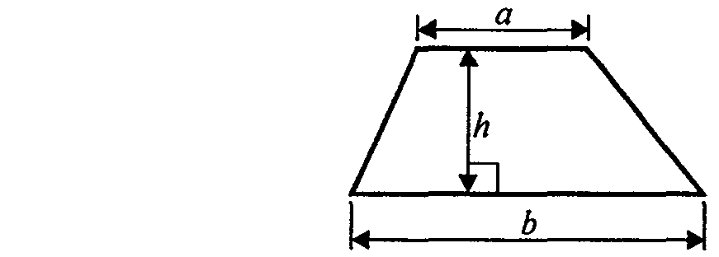

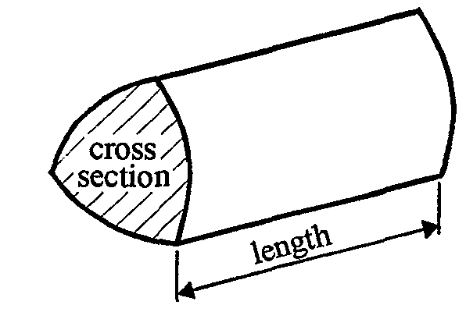

Volume of prism = area of cross section x length
Foundation – Section A - Calculator

1. (a) Write the number three thousand, five hundred and twelve in figures.

……………………..
(1)
- Write down the value of the 4 in the number 274 863

……………………..
(1)
(Total 2 marks)

2. Here are some patterns made with dots.

- In the space below, complete Pattern Number 4.

(1)

The table shows the number of dots used to make each pattern.

(b) Complete the table
Pattern Number | 1 | 2 | 3 | 4 | 5
Number of dots | 5 | 8 | 11
(2)
(Total 3 marks)

3. (a) Find the value of

3.7²

……………………………
(1)
The table shows some numbers.
51 | 52 | 53 | 54 | 55 | 56 | 57 | 58 | 59

Two of the numbers are prime numbers.

(b) Put a tick () underneath each of these two numbers.
(2)
(Total 3 marks)

4. (a) Write 11% as a fraction.

……………………..
(1)
(b) Write 0.25 as a percentage.

……………………..%
(1)
(c) Write 8% as a decimal.

……………………..
(1)
(d) Work out 40% of 200.

……………………..
(2)
(Total 5 marks)

5. (a) Work out the value of

Write down all the figures on your calculator.

……………………………….
(2)

- Give your answer to (a) correct to 1 significant figure.
………………
(1)
(Total 3 marks)

6.
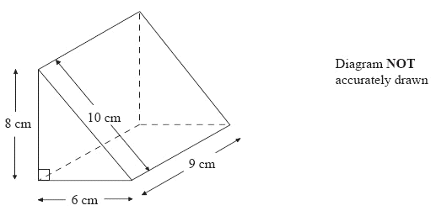
Work out the surface area of the triangular prism.
State the units with your answer.

…………………….
(Total 4 marks)

7. Mr Holland uses 367 units of electricity in one month.
He pays 5.84p for each unit of electricity.
Mr Holland also pays a fixed charge of £6.14 for the month.

Work out the total amount he pays.

£ …………………
(Total 3 marks)

8. Daniel drives 75 kilometres to work.
He drives at an average speed of 60 miles per hour.
How long does his journey take?

…………………………hours
(Total 2 marks)

Total : 25 marks
Foundation – Section B – Non-calculator

- Write these numbers in order of size.
Start with the smallest number.

(i) 0.54, 0.047, 0.4, 0.45, 0.405

...........................................................................................
- 5, − 3, − 13, 2, − 2

...........................................................................................
(Total 2 marks)

2. Hannah buys
2 pens at 70p each
3 folders at £2.10 each
1 pencil case at £1.50

She pays with a £10 note.
Work out how much change Farah should get from £10

£ …………………
(Total 3 marks)

3. (a) Complete the table of values for y = 2x + 1

x | −2 | −1 | 0 | 1 | 2
y |  | −1 |  | 3
(2)
(b) On the grid, draw the graph of y = 3x + 2

(2)
(Total 4 marks)

4.
Diagram NOT accurately drawn
3 cm

10 cm

(a) Work out the area of the rectangle.

..........................cm²
(1)

Diagram NOT accurately drawn
5 cm
3 cm

4 cm

(b) Work out the perimeter of the triangle

..........................cm
(2)
(Total 3 marks)

5. (a)
Diagram NOT accurately drawn
PQR is a straight line.
SQ = SR.

- Work out the size of the angle marked x°

..........................°
- Give reasons for your answer.

...........................................................................................................................

...........................................................................................................................
(3)
(b)
Diagram NOT accurately drawn
DE is parallel to FG.

(i) Find the size of the angle marked y°.

..........................°
(ii) Give a reason for your answer.

...........................................................................................................................
(2)
(Total 5 marks)

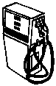
6. A litre of petrol costs 84p.
Work out the cost of 26 litres of petrol.
Give your answer in pounds.

£ …………………………
(Total 3 marks)

7. (a) Simplify

(i) 3g + 5g
.................................
(ii) 2r × 5p
.................................
(2)

(b) Factorise 3x + 12

………………….
(1)
(c) Expand and simplify

2(3x + 4) + 3(4x – 5)

.................................
(2)
(Total 5 marks)

Total : 25 marks

BLANK PAGE

Practice Paper E Foundation Unit 3 – Answers

Section A

1. (a) 3512 (b) thousands or 1000 or 4000

2. (a) See their diagram (b) 14, 17

3. (a) 13.69 (b) 53 and 59

4. (a) (b) 25 (c) 0.08 (d)  100 = 80

5. (a) 114.3 (b) –100

6. 2 × × 6 × 8 + 8 × 9 + 6 × 9 + 10 × 9 = 48 + 72 + 54 + 90 = 264 cm²

7. 367  5.84  614 = 2757.28 2757p or 27.57

8. 75  60 = 1.25
1.25 hours or 1 hours

Section B

1. (i) 0.047, 0.4, 0.405, 0.45, 0.54 (ii) 13, 3, 2, 2, 5

2. 2  70p + 3  £2.10 + £1.50
= £1.40 + £6.30 + £1.50
= £9.20
£10  £9.20 = £0.80

3. (a) – 3, 1, 5 (b) line drawn

4. (a) 30 cm² (b) 12 cm

5. (a) (i) 130
(ii) Isosceles triangle or two angles equal
(b) (i) 64
(ii) Alternate angles

6. 84  26 = 2184p = £21.84

7. (a) (i) 8g
(ii) 10rp
(b) 10y  15
(c) 6x + 8  12x  15 = 18x – 7

