

GCSE in Mathematics B
Modular 2544
Unit 3 Number, Algebra, Shape Space and Measures 1
Practice Paper D
Foundation
(Calculator and Non – Calculator)
Formulae Sheets
EDEXCEL

GCSE Mathematics

Formulae Sheet Foundation Tier

Area of trapezium = $\frac{1}{2}$(a + b)h
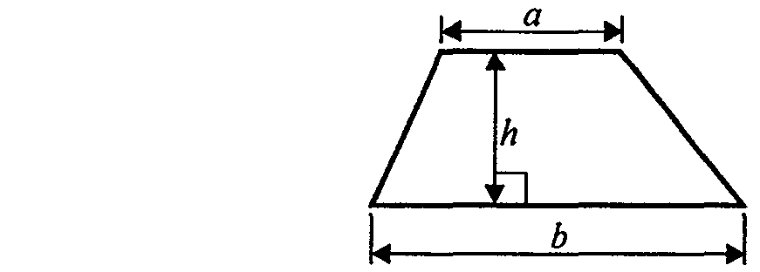

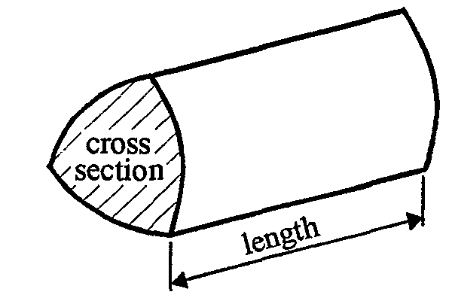

Volume of prism = area of cross section x length
Foundation – Section A - Calculator

1. 6782 people watched a concert.

(a) Write 6782 to the nearest hundred.

....................................
(1)
(b) Write down the value of the 8 in the number 6782

....................................
(1)
(Total 2 marks)

2.
Box
Carton
Diagrams NOT accurately drawn

A light bulb box measures 6 cm by 6 cm by 10 cm.
Light bulb boxes are packed into cartons.
A carton measures 30 cm by 30 cm by 80 cm.
Work out the number of light bulb boxes which can completely fill one carton.

.......................... boxes
(Total 3 marks)

3. (a) Work out the value of (2 + 3) × 4 + 5

…………………
(1)

- Add brackets ( ) to make this statement correct.
You may use more than one pair of brackets in this statement.

2 + 3 × 4 + 5 = 29

(1)
(Total 2 marks)

4. There are 800 students at Prestfield School.
144 of these students were absent from school on Wednesday.

(a) Work out how many students were not absent on Wednesday.

..........................
(2)
Trudy says that more than 25% of the 800 students were absent on Wednesday.

(b) Is Trudy correct? Explain your answer.

(2)
45% of these 800 students are girls.

(c) Work out 45% of 800

..........................
(2)
(Total 6 marks)

5. (a) Work out the value of 3.8² –
Write down all the figures on your calculator display.

…………………….
(2)
- Write your answer to part (a) correct to 1 significant figure.

…………………….
(1)
(Total 3 marks)

6. Here is a list of 8 numbers.

11 16 18 36 68 69 82 88

(a) Write down a number from the list which is

- a multiple of 9

……………………..
- a square number.

……………………..
(2)
-
cube | multiple | factor | product

(b) Use a word from the box to complete this sentence correctly.

11 is a …………..…………… of 88
(1)
(Total 3 marks)

7. The diagram shows a car park.
Mrs Roberts is selling the car park. She will accept any offer that is more than £28 per square metre.
Mr Patel offers £194 700 for the car park.
Will Mrs Roberts accept Mr Patel’s offer for the car park?
You must show how you reached your decision.

Decision ………………….
(Total 6 marks)

Total : 25 marks

Foundation Section B – Non-Calculator

- Here are the first five terms of a number sequence.

3 8 13 18 23

(a) Write down the next two terms of the sequence.
............, ............
(2)
- Explain how you found your answer.

.....................................................................................................................................
(1)
- Explain why 387 is not a term of the sequence.

.....................................................................................................................................

.....................................................................................................................................
(1)
(Total 4 marks)

2. Julie buys

1 calculator costing £5.85
1 pad of paper costing £1.40
2 pencils costing £0.45 each

She pays with a £10 note.

Work out how much change she should get.

£…………………….
(Total 3 marks)

3.
PQ is a straight line.

- Work out the size of the angle marked x°.

..............................°
(1)

(b) (i) Work out the size of the angle marked y°.

..............................°
(ii) Give reasons for your answer.
...................................................................................................................

...................................................................................................................
(3)
(Total 4 marks)

4. (a) Complete the table of values for x + y = 5
x | –1 | 0 | 1 | 2 | 3
y | 6 |  |  |  | 2
(2)
(b) On the grid, draw the graph of x + y = 5

(2)
(Total 4 marks)

5. Work out an estimate for the value of $\frac{\text{637}}{3\text{.}2 × 9\text{.}8}$

……………………..
(Total 2 marks)

6. (a) Simplify m + m + m + m

……………………..
(1)

(b) Simplify k  k

………………….
(1)
(c) Simplify 3y2 – y2

……………………..
(1)
(d) Simplify 5c + 7d – 2c – 3d

……………………..
(2)
(e) Simplify 4p × 2q

……………………..
(1)
(Total 6 marks)

7. Expand and simplify (y – 5)(y + 4)

…………………………..
(Total 2 marks)

Total 25 marks

Practice Paper D

Foundation Unit 3 – Answers

Section A

1. (a) 6800 (b) 80 or 10 or tens
- 30  30  80  6  6  10 or 30  6  306  80  10 = 200

3. (a) 25 (b) 2 + 3 × (4 + 5) = 29
4. (a) 800 – 144 = 656 (b) 25% of 800 = 200 ; less than 25% absent
(c) $\frac{\text{45}}{\text{100}} × \text{800}$ = 360
5. (a) 5.779745962 (b) 6
6. (a) (i) 18 or 36 (ii) 16 (b) factor
- 120  20 + $\frac{1}{2}$  (120 – 42)  (140 – 20) = 2400 + 4680 = 7080
7080  28 = 198,240
She will accept an offer over £198,240 so offer not acceptable

Section B

1. (a) 28, 33 (b) added on 5 (c) does not end in 3 or 8
2. £1.85
3. (a) 54º (b) (i) 72º (ii) isosceles triangle; angles in a triangle add to 180º
- (a) 5, 4, 3 (b) line drawn

5.600  30 = 20
- (a) 4 m (b) k² (c) 2y² (d) 3c + 4d (e) 8pq

- y² – y – 20

