

GCSE in Mathematics B
Modular 2544
Unit 3
Number, Algebra, Shape Space and Measures 1
Practice Paper C
Foundation
(Calculator and Non – Calculator)
Formulae Sheets
EDEXCEL

GCSE Mathematics

Formulae Sheet Foundation Tier

Area of trapezium = $\frac{1}{2}$(a + b)h
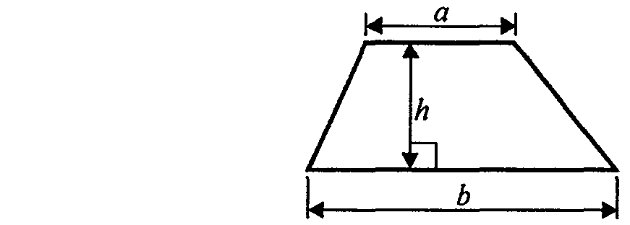

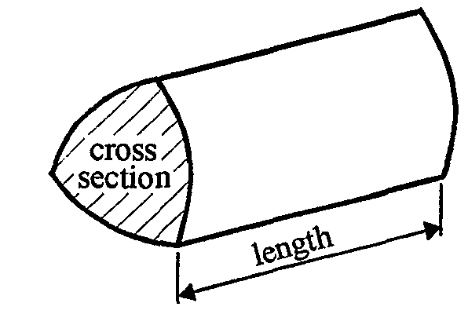

Volume of prism = area of cross section  length
Foundation – Section A - Calculator

1. (a) Write the number seventeen thousand, two hundred and fifty-two in figures.

……………………..
(1)
- Write the number 5367 correct to the nearest hundred.

……………………..
(1)
- Write down the value of the 4 in the number 274 863

……………………..
(1)
(Total 3 marks)

2. (a) Work out the value of 2 + .

…………………..
(1)
- Write these numbers in order of size.
Start with the smallest number.

(i) 0.68, 0.6, 0.086, 0.86, 0.608

………………………………………..

(ii) –4, –6, –3, 0, 1

…………………………………………..
(2)
(c) Find the cube of 5

………………….
(1)
(Total 4 marks)

3. (a) Write down a sensible metric unit that should be used to measure:

- the height of a school hall,

...................................
- the weight of a pencil.

...................................
(2)

- Write down a sensible imperial unit that should be used to measure the distance between London and Manchester.

...................................
(1)
(Total 3 marks)

4. Maggie buys
1 kg of carrots at 64p per kg,
4 cakes at 35p each,
6 tins of soup at 43p each.

She pays with a £10 note.
Work out how much change she should get.

£ ………………..
(Total 4 marks)

5. (a) Use your calculator to work out

(2.3 + 1.8)² × 1.07

Write down all the figures on your calculator display.

.....................................
(2)

(b) Write your answer to (a) correct to 1 significant figure.

………………………
(1)
(Total 3 marks)

6.

A shaded shape is shown on the grid of centimetre squares.

- Find the area of the shaded shape.

……………………………cm²
(1)
- Find the perimeter of the shaded shape.

……………………………cm
(1)
(Total 2 marks)

7. (a) Expand t(t – 2)

..........................
(1)
- Factorise 3y – 12

..........................
(1)
(Total 2 marks)

8.
Diagram NOT accurately drawn
6 cm
4 cm
9 cm

A cuboid has
a length of 9 cm,
a width of 6 cm,
a height of 4 cm.

Work out the volume of the cuboid.

……………………………. cm³
(Total 2 marks)

9. Find the Highest Common Factor (HCF) of 24 and 36

…………………………….
(Total 2 marks)

Total 25 marks

Foundation –Section B – Non-Calculator

- Adam makes some patterns using sticks.

(a) Draw Pattern Number 4 in the space above.
(1)
(b) Complete the table.
Pattern Number | 1 | 2 | 3 | 4 | 5
Number of sticks | 5 | 9 | 13
(1)
(Total 2 marks)

2.
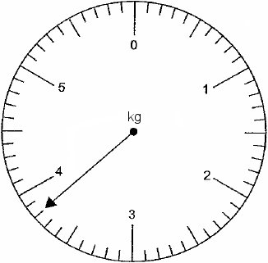

- Write down the reading shown on the scale.

.......................... kg
(ii) Change 5.7 kg to grams.

.......................... g
(Total 2 marks)

3. Here is a map of the British Isles.
The temperatures in some places, one night last winter are shown on the map.
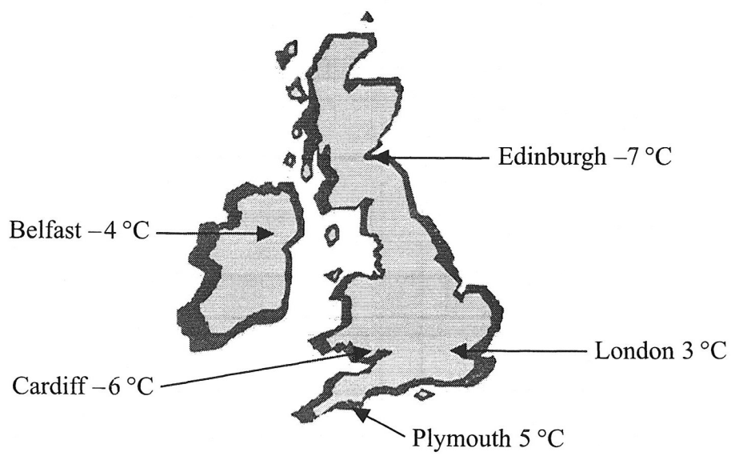

(a) (i) Write down the names of the two places that had the biggest difference in temperature.

.......................................... and ......................................................

(ii) Work out the difference in temperature between these two places.

............................°C
(Total 3 marks)

4. (a) Simplify

m + m + m + m
………………………….
(1)
- Simplify

3  a  2
……………………………
(1)
- Simplify

5p + 7q + 3p – 4q

……………………………
(2)

- Expand and simplify

(x – 3)(x – 5)

……………………
(2)
(Total 6 marks)

5.

(a) Write down the coordinates of the point P.
( …... , …... )
(1)
The point Q has coordinates (4, −2).

(b) On the grid, plot and label the point Q.
(1)
(Total 2 marks)

6. (a) Write down the special name for this type of angle.

.......................
(1)
(b) Write down the special name for this type of angle.

.........................
(1)
(c)

This diagram is wrong. Explain why.

.....................................................................................................................................

.....................................................................................................................................
(1)
(Total 3 marks)

7.
Diagram NOT accurately drawn

Write down the size of

(i) x, x = …………….…

(ii) y. y = …………….…
(Total 2 marks)

- Work out 35.4  6.2

…………………..
(Total 3 marks)

- Here are the first 5 terms of an arithmetic sequence.

6, 11, 16, 21, 26

Find an expression, in terms of n, for the nth term of the sequence.

.................................................
(Total 2 marks)

Total 25 marks

Practice Paper C

Unit 3 Foundation – Answers

Section A

1. (a) 17252 (b) 5400 (c) 4000 or 1000 or thousand
2. (a) 12 (b) (i) 0.086, 0.6, 0.608, 0.68, 0.86 (ii) –6, −4, −3, 0, 1 (c) 125
3. (a) (i) metres (ii) grams (b) miles
4. 1.5  64 + 4  35 + 6  43 = 494
10 – 4.94 = £5.06
5. (a) 17.9867 (b) 20
6. (a) 29 cm² (b) 24 cm
7. (a) t² – 2t (b) 3(y – 4)
8. 9  6  4 = 216 cm³
9. 12

Section B
1. (a) pattern (b) 17, 21
2. (i) 3.8 kg (ii) 5700 g
3. (i) Edinburgh and Plymouth (ii) 12ºC
4. (a) 4m (b) 6a (c) 8p + 3q (d) x² – 8x + 15
5. (a) (−3, 2) (b) (4, −2) plotted
6. (a) acute (b) reflex (c) Angles sum to 350º should be 360º
7. (i) 37º (ii) 62º
8. 219.48
9. 5n + 1

