

GCSE in Mathematics B
Modular 2544
Unit 3
Number, Algebra, Shape Space and Measures 1
Practice Paper B
Foundation
(Calculator and Non – Calculator)
Formulae Sheets
EDEXCEL

GCSE Mathematics

Formulae Sheet Foundation Tier

Area of trapezium = $\frac{1}{2}$(a + b)h
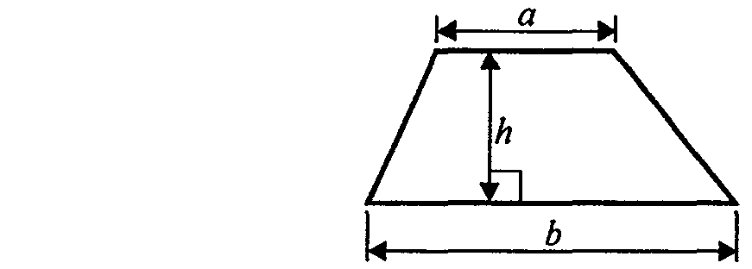

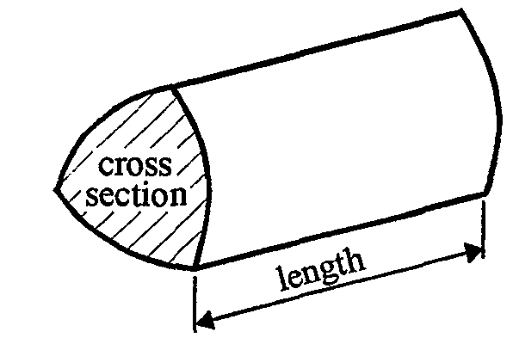

Volume of prism = area of cross section  length
Foundation – Section A - Calculator

1. Here are some patterns made from matchsticks:

(a) Draw Pattern number 4.

(1)
(b) Complete this table for the pattern sequence.
Pattern number | 1 | 2 | 3 | 4 | 5
Number of matchsticks used | 4 | 7 | 10

(1)
(Total 2 marks)

2. (a) Write three hundred and fifty thousand in figures.
……………….
(1)
(b) Write 25 400 in words.

…………………………………………………………………………………...
(1)
(c) Write 25 730 correct to the nearest thousand.

………………….
(1)
(Total 3 marks)

3. (a) Write down the name of a metric unit which is used to measure:

(i) the distance from London to Brighton,
……………………………
(ii) the weight of a bar of soap.
……………………………
(2)
(b) (i) Change 240 millimetres to centimetres.

……………………………cm
(ii) Change 3.8 litres to millilitres.

……………………………ml
(2)
(Total 4 marks)
4.

A shaded shape has been drawn on the centimetre grid.

(a) Work out the perimeter of the shaded shape.

………………cm
(1)

Diagram NOT accurately drawn

This solid shape is made from cubes of side one centimetre.

(b) Work out the volume of the solid shape.

………………… cm³
(2)
(Total 3 marks)

5. (a) Simplify
2x × y × 3
……………………………
(1)
(b) Simplify
5x + 3y  2x + y
……………………………
(2)
(c) Multiply out
5(3x + 7)
……………………………
(1)
(Total 4 marks)

6.
The diagram shows a shape.
Work out the area of the shape.

…………………………… cm2
(Total 3 marks)

7. (a) Complete the table of values for y = 3x + 2
x | –2 | –1 | 0 | 1 | 2
y |  | –1 |  | 5
(2)
(b) On the grid, draw the graph of y = 3x + 2

(2)
(Total 4 marks)

8. Here are the first 4 terms of an arithmetic sequence

3 7 11 15

Find an expression, in terms of n, for the nth term of the sequence.

…………………………
(Total 2 marks)

Total : 25 marks
Foundation – Section B – Non-calculator

1. (a) Write these numbers in order of size. Start with the smallest number.

(i) 0.57, 0.5, 0.057, 0.55, 0.507
………………………………………..
(ii) 6, 4, 2, 1, 3
…………………………………………..
(2)
(b) Find the cube of 5

………………….
(1)
(c) Find the value of 10⁴
………………….
(1)
(Total 4 marks)

2.

(a) Write down the coordinates of the point A.
(……….…, …………)
(1)
The point B has coordinates (3, 2).

(b) On the grid, plot and label the point B.
(1)
(Total 2 marks)

3.

- Write down the name of this quadrilateral.

……………….
(1)
(b) Mark, with the letter A, an acute angle.
(1)
(Total 2 marks)

4.
Diagram NOT accurately drawn

105º
xº

- Work out the size of the angle marked x.

……………….º
(1)
(b) Give a reason for your answer.

…………………………………………………………………………………………………...
(1)
(Total 2 marks)

5. (a) Write 0.060 172 correct to 1 significant figure.
………………….
(1)
(b) Write 28 473 correct to 1 significant figure.
……………………
(1)
(Total 2 marks)

6. (a) Work out the value of (2 + 1) × 4 + 5

…………………
(1)
(b) Add brackets ( ) to make each statement correct.
You may use more than one pair of brackets in each statement.

(i) 2 + 3 × 4 + 5 = 25

(ii) 2 + 3 × 4 + 5 = 45
(2)
(Total 3 marks)

7.

Write these fractions in order of size.
Start with the smallest fraction.

..............................................................................
(Total 2 marks)

8. The table shows temperatures at midnight and midday on one day in five cities.
City | Midnight temperature | Midday temperature
Belfast | −1 °C | 5 °C
Cardiff | −2 °C | 3 °C
London | −8 °C | −1 °C
Manchester | −3 °C | 1 °C
York | −6 °C | 4 °C

(a) Which city had the lowest midnight temperature?

…………………………….
(1)
(b) At midnight, how many degrees higher was the temperature in Cardiff than York?

…………..°C
(1)
(c) Which city had the smallest rise in temperature from midnight to midday?

…………………………….
(1)
(Total 3 marks)

9. Factorise 3y + y²

...............................
(Total 1 marks)

10. Work out an estimate for the value of $\frac{7\text{.}8 × 5\text{.}3}{\text{10}\text{.}3}$

…………………………
(Total 2 marks)

11. Simplify

(a) 4⁵  4³
………………
(1)

(b) 4¹³  4³

………………..
(1)
(Total 2 marks)

Total 25 marks

BLANK PAGE

Practice Paper B

Unit 3 Foundation – Answers

Section A

1. (a) pattern (b) 13, 16
2. (a) 350 000 (b) Twenty five thousand four hundred (c) 26 000
3. (a) (i) kilometres (ii) grams (b) (i) 24 cm (ii) 3800 ml
4. (a) 22cm (b) 15 cm³
5. (a) 6xy (b) 3x + 4y (c) 15x + 35
- 8  9 + $\frac{1}{2}$  (20 – 8)  (9 – 4) = 102 cm²
7. (a) –4, 2, 8 (b) straight line
- 4n – 1

Section B

1. (a) (i) 0.057, 0.5, 0.507, 0.55, 0.57 (ii) − 4, − 3, − 1, 2, 6
(b) 125 (c) 10000
2. (a) (−2, 1) (b) (3, −2) plotted
3. (a) trapezium (b) correct angle marked
4. (a) 75º (b) Angles on a straight line sum to 180º
5. (a) 0.06 (b) 30000
6. (a) 17 (b) (i) (2 + 3)  4 + 5 (c) (2 + 3)  (4 + 5)

8. (a) London (b) 4° C (c) Manchester
9. y(3 + y)
10. = 4
11. (a) 4⁸ (b) 4¹⁰

