

GCSE in Mathematics B
Modular 2544
Unit 3
Number, Algebra, Shape Space and Measures 1
Practice Paper A
Foundation
(Calculator and Non – Calculator)
Formulae Sheets
EDEXCEL

GCSE Mathematics

Formulae Sheet Foundation Tier

Area of trapezium = $\frac{1}{2}$(a + b)h
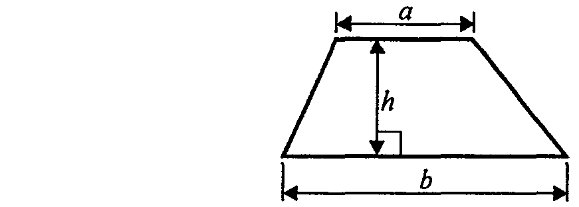

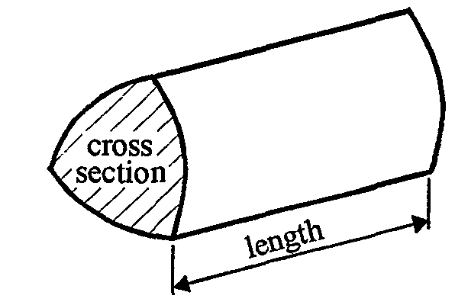

Volume of prism = area of cross section  length
Foundation – Section A – Calculator

1. 54 327 people watched a concert.

(a) Write 54 327 to the nearest thousand.

....................................
(1)
(b) Write down the value of the 5 in the number 54 327

....................................
(1)
(Total 2 marks)

2. Write these numbers in order of size.
Start with the smallest number.

(i) 0.39, 0.4, 0.049, 0.49, 0.409
………………………………………..
(ii) 4, 3, 1, 5, 7
………………………………………..
(Total 2 marks)

3. Complete this table
Write a sensible unit for each measurement.

 | Metric | Imperial
The weight of a turkey | ......................... | pounds
The width of this page | centimetres | .........................
(Total 2 marks)

4. Farah buys
2 pens at 84p each
3 folders at £1.35 each
1 pencil case at £1.49

She pays with a £10 note.
Work out how much change Farah should get from £10

£ ……………………………
(Total 3 marks)

5. A shaded shape has been drawn on the centimetre grid.

(a) (i) Find the area of the shaded shape.
…………………cm2

(ii) Find the perimeter of the shaded shape.
………………….cm
(Total 2 marks)

6. (a) Simplify

(i) c + c + c + c
.....................
(ii) p × p × p × p
.....................
(iii) 2r × 5p
.....................
(3)
(b) Expand

5(2y – 3)
.....................
(1)
(Total 4 marks)

7. Mr Johnson works out the cost of the gas he used last year.
At the start of the year, the gas meter reading was 8569 units.
At the end of the year, the gas meter reading was 9872 units.
Each unit of gas he used cost 44p.

Work out the total cost of the gas he used last year.

£ ……………………………
(Total 4 marks)

8.

(i) Work out the size of the angle marked x°.

………………..°
(ii) Give a reason for your answer.

..……………………………………………………………………………………….……

..………………………………………………………………………….…………………
(Total 2 marks)

9. Jack travelled 90 kilometres in 1 hour and 15 minutes.

Work out Jack’s average speed.
Give your answer in kilometres per hour.

£ .............................
(Total 2 marks)

10. Here are the first five terms of an arithmetic sequence.

6 10 14 18 22

Find, in terms of n, an expression for the nth term of the sequence.

…………………….
(Total 2 marks)

Total : 25 marks
Foundation –Section B – Non-Calculator

1. Here is a list of seven numbers

6 8 9 12 14 20 23

From the list, write down

(a) a square number,

…………
(1)
(b) a number that is a multiple of 7,

…………

(1)
(c) two numbers that are factors of 40,

…………
(1)
(d) two numbers with a difference of 9.

…………
(1)
(Total 4 marks)

2. (a) Work out

41.3 × 100
…………
(1)
(b) Work out

0.4 × 0.6
…………
(1)
(c) Work out

5.2  1.37
…………
(1)
(Total 3 marks)

3. Here are some fractions.

Two of the fractions are not equivalent to
Tick the boxes underneath each of these two fractions.
(Total 2 marks)

4. Simplify
8x + 5y – 3x + y

……………………………
(Total 2 marks)

5. Factorise x² + 6x

…………………
(Total 2 marks)

6.
Diagram NOT accurately drawn

(a) Work out the value of x.
x = ………….
(1)
(b) Work out the value of y.

y = ………….
(2)
(Total 3 marks)

7. (a) Complete the table of values for y = 2x + 3
x | –2 | –1 | 0 | 1 | 2 | 3
y |  | 1 | 3
(2)
(b) On the grid, draw the graph of y = 2x + 3
(2)
(Total 4 marks)

8. Work out 286 × 43

……………………..
(Total 3 marks)

9. Find the Highest Common Factor (HCF) of 32 and 80

..................................
(Total 2 marks)

Total 25 marks

BLANK PAGE

Practice Paper A

Unit 3 Foundation – Answers

Section A
1. (a) 54000 (b) fifty thousand or ten thousand
2. (a) (i) 0.049, 0.39, 0.4, 0.409, 0.49 (b) −7, −5, −3, 1, 4
- kilograms, inches

4. 2  0.84 + 3  1.35 + 1.49 = 7.22; 10 – 7.22 = £2.78
5. (a) 11 cm² (b) 16 cm
6. (a) (i) 4c (ii) p⁴ (iii) 10rp (b) 10y – 15
- (9872 – 8569)  44 = 57332p = £573.32

- (i) 110° (ii) angles at a point sum to 360º

- 72 km/h

- 4n + 2

Section B

1. (a) 9 (b) 14 (c) 8, 20 (d) 14, 23
2. (a) 4130 (b) 0.24 (c) 3.83
- $\frac{3}{\text{10}}$, $\frac{8}{\text{24}}$
- 5x + 6y
- x(x + 6)
- (a) 137° (b) 29°
- (a) –1, 5, 7 (b) Correct line
- 12298
- 16

